Regional Training of Trainers’ Workshop on Community Led Total Sanitation in Thaba Tseka District, Lesotho

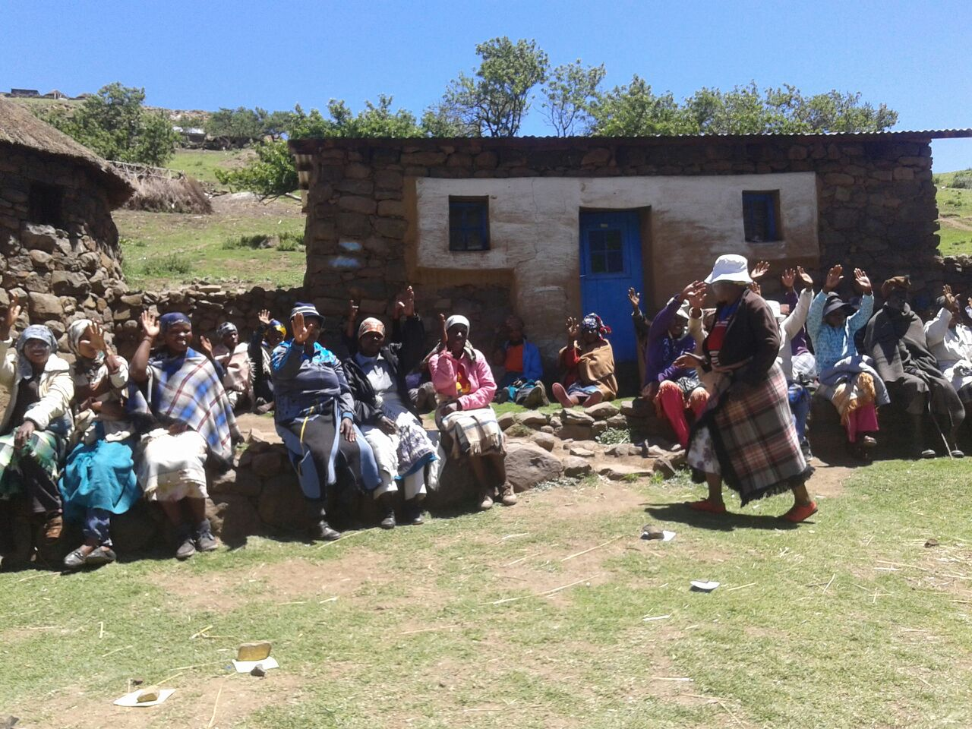

13th – 19th November 2014
Held in Thaba Tseka
Workshop Report
CLTS Foundation Global
CB 88, Sector 1, Salt Lake City, Kolkata, India.
(E): cltsfoundationglobal@gmail.com (W): www.cltsfoundation.org
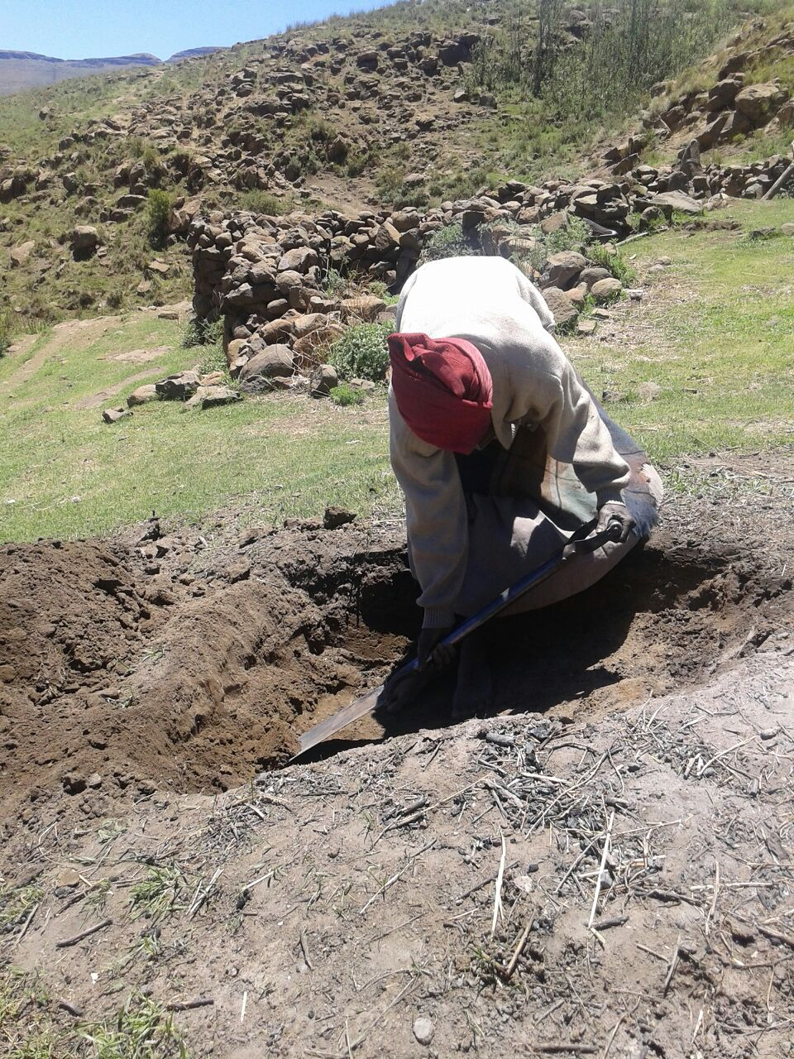 | 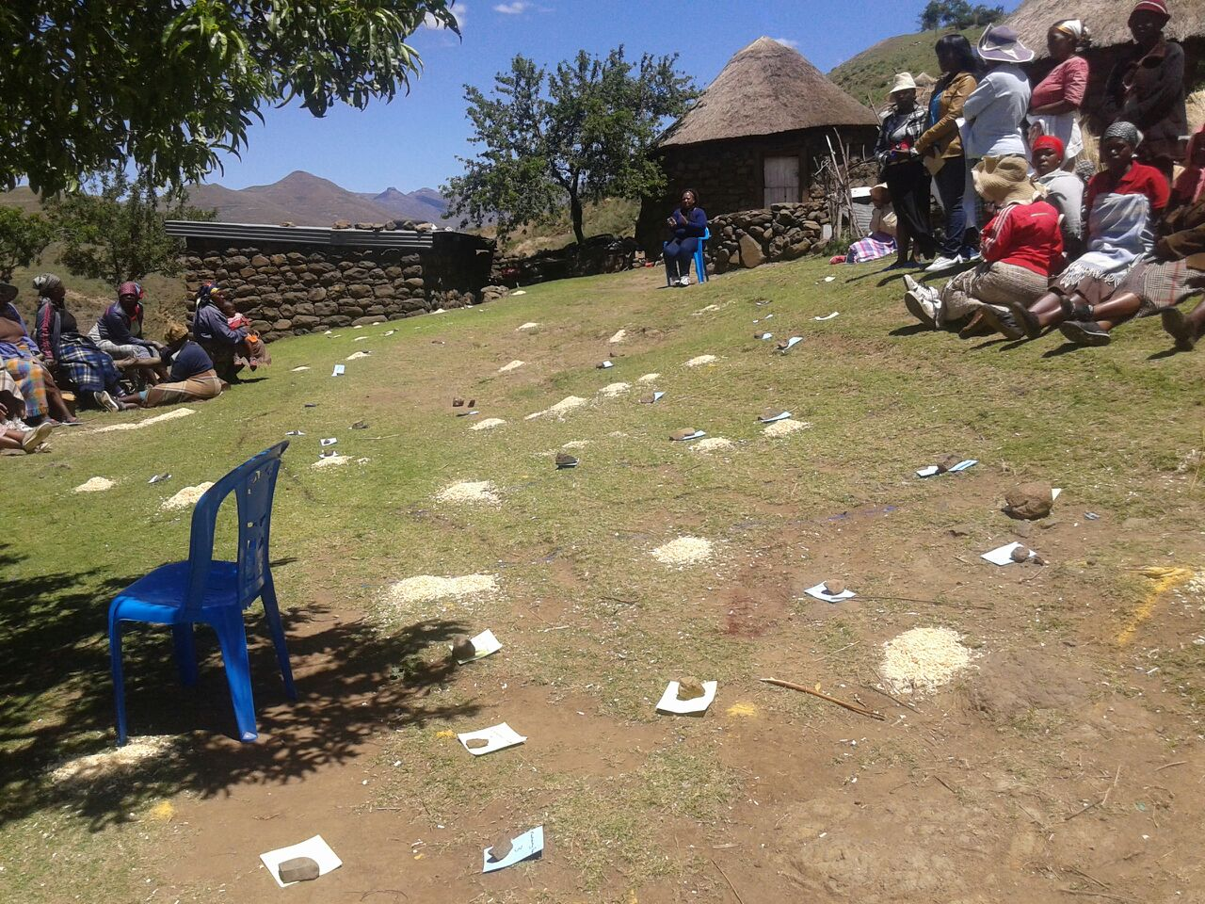 | 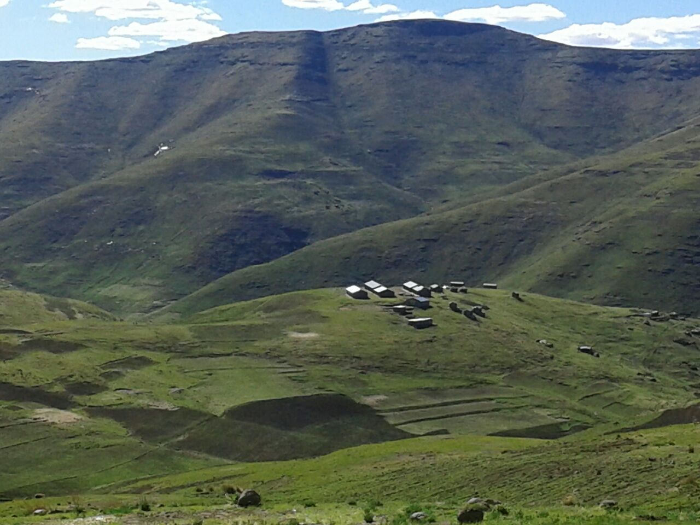

Table of Contents

Background and Introduction 4
DAY 1: Thursday 13th October, 2014 4
1: Opening Session 4
Inauguration 4
Opening Address 4
Keynote address 4
Opening remark form Dr. Kamal Kar: 5
Introduction of participants / ice breaker 5
1.1 Mapping out Expectations and objectives: 5
1.2: Setting the Objectives of the Workshop: 5
1.3: Why CLTS: 6
Technical Session II: 7
2.1 Attitude and Behaviour Change / Do's and Don'ts 7
Behaviour and attitude changes of outsiders are essential for the successful facilitation of CLTS. CLTS operates on three key behavioural rules: 7
2.2: Dos and Don’ts 8
Session III: Group formation and roles and responsibilities 9
DAY 2: Friday, 14th November 2014 10
Session-IV: Technical Session: Stages and Tools of CLTS 10
CLTS operates on three key behavioural rules: 10
Pre triggering 10
Triggering Part A: visual analysis by the community. 11
Triggering Part B: Encouragement to continue and build platform for post-triggering 11
Technical Session V: Presentation on CLTS including Global Experience 12
Day 3: 15th December 2014, Saturday 12
Technical Session VI: 12
6.1: Developing group strategies for triggering exercises 12
DAY 4: 17th December 2014, Monday 13
Session VII: Practical Field Demonstration 13
Feedback on morning triggering 13
DAY 5: 18th November 2014, Tuesday 14
8: Session VIII: Practical field demonstration: 14
9. Session IX: Feedback on morning triggering 14
10. Session X: Post triggering follow up and post ODF activities 15
10.1: Post triggering follow up actions: 15
10.2: Post ODF Activities 15
11: DAY 6: 19th November 2014: Wednesday 15
Session XI: Preparation of action plans for next six months: 15
12: Session XII: communities presentation: 16
12.1: Natural Leaders' presentations 16
Workshop evaluation 17
Key Observations and Conclusion: 17

Background and Introduction
CLTS Foundation, as a part of its collaborative efforts with Eastern Southern Africa Region of UNICEF, has made a sincere effort to introduce CLTS in Lesotho on the interest of UNICEF and Government of Lesotho. Lesotho is a country with a very disturbing statistics with regard to child survival. The under five-child mortality is very high with 121 deaths from 1000 child births. The sanitation link is quite evident as RTI, diarrhoea, pneumonia and HIV cause major deaths. While HIV kills about 19%, diarrhoea kills 10% and RTI kills 12% and pneumonia kills another 12% of children. About 41% of new-born deaths are caused by various infections. Moreover the human resource potential is strongly hindered with about 39% children suffering from stunting which has clear links with Open defecation related issues.

This report details the proceedings of the Training of Trainers’ Workshop on CLTS held in Thaba Tseka Region from 13th to 19th November 2014 organised by the UNICEF and Department of Water Resources and Environment. There were around 80 participants invited from across all 10 districts of the country. The majority of participants were from Department of Water Resources and Department of Public Health but potential collaborators in CLTS from NGOs like Red Cross, Ministry of Local Governance, Ministry of Education etc. The schedule of the workshop can be found in Annex 1.

DAY 1: Thursday 13th October, 2014

1: Opening Session

Inauguration
Dr. Victor Ankhra, Chief of Health, and UNICEF Lesotho made the inaugural remark. He welcomed all the participants and spoke about the purpose and relevance of this training workshop. In his introductory remark Dr. Victor brought everybody’s attention to the striking statistics which is that about 6000 children die every year and 1000 of them are because of diarrhoea and pneumonia that is basically caused by open defecation practices. He closed his brief opening remarks with introducing the dignitaries on the dais and the two trainers; Dr Kamal Kar and Sisir Kanta Pradhan.

Opening Address
Mr. Ntate Tlali Hlasa, the director Rural Water Supply welcomed all the participants of the workshop. He recalled the Government of Lesotho’s commitment in Zambia to obtain full sanitation coverage of the country. Within three months of the Zambia meeting, the sanitation committee was formed with a definitive role of facilitating access to basic sanitation across the country. They tried out various approaches and the national team also visited a country, which has attained strong progress in sanitation coverage by adopting the CLTS approach. But there has been a constant dilemma whether CLTS is feasible in the Lesotho context. He expressed his gratitude to the CLTS Foundation team and UNICEF to organise a Training of Trainers workshop on CLTS that will spur the efforts of Government of Lesotho to introduce CLTS as a key sanitation strategy to achieve faster and lasting change in sanitation scenario of Lesotho. While he thanked all the actors who matter in organising such a workshop, he also urged all the participants to take full advantage of the time and learnings from the workshop. He concluded his remarks by officially declaring the workshop open.

Keynote address

The UNICEF country representative Dr.Tesfaye Shiferaw, emphasised UNICEF’s persistent efforts to put Lesotho in map of Countries making good progress towards eliminating Open Defecation. The objective is to bring dignity to the community by eliminating open defecation and cleaning up the community. Being a physician, drawing from his personal experience he reiterated the fact that most people who reported illnesses of different kinds such as diarrhoea practice open defecation or have poor sanitation practices. It is very important, especially in Lesotho where there is a high prevalence of diarrhoea and child mortality. He categorically appealed to all the participants to be very alert as the workshop is going to be path breaking as CLTS approach has done wonders in many countries.

Opening remark form Dr. Kamal Kar: Taking the lead from the keynote speaker Dr. Kamal Kar reiterated the enormity of the problem due to open defecation. He said that Government must have spent millions of dollars in sanitation with very limited success. Hence there is a need for a renewed thinking on sanitation approach in the country.

Introduction of participants / ice breaker
Participants introduced themselves by name and the district they represent. Each one was also asked to reveal about when s/he did Open Defecation last time. The self-introduction was followed with a participatory exercise where participants formed groups according to their region of birth; place of birth, the number of children they have; organisation/ departments they represent, professional qualifications etc. This exercise helped the participants to know little more about each other.

Technical Session 1

1.1 Mapping out expectations and objectives:
The participants were divided into five groups for brain storming on mapping out the expectations from the workshop. Participants shared their expectations of the workshop on cards, which were further sorted into few thematic groups. The broad thematic groups of expectations are as follow:
- Knowledge of CLTS
- CLTS Skills
- Reporting and M&E: know how to report on CLTS; learn M&E in CLTS
- Sustainability: to learn how to sustain ODF communities, is it a project or on going exercise?
- Institutional collaboration: inter sectoral collaboration, interaction among all relevant stakeholders
- Technology
- CLTS and MDG
- Support by the CLTS Foundation
- Further inputs; study tour to successful countries
- Experience sharing

1.2: Setting the Objectives of the Workshop:
These expectations were then matched against the proposed objectives of the workshop. These were that by the end of the six days ‘hands-on’ training workshop all participants will have:

- Gained clear understanding and knowledge on the principles, rationale, methodology, applicability and limitations of Community Led Total Sanitation (CLTS).

- Gained and strengthened skills of facilitating CLTS with rural communities.

- Gained clear understanding of post triggering follow up strategy for successful implementation of CLTS.

- Sharpened training skills in order to render quality training to the facilitators and future trainers of CLTS.

- Shared experiences of triggered communities as outcome of triggering carried out during the workshop.

- Outlined institutional/organisation plans of action for next 6 months.

All participants agreed that the objectives covered their expectations and they had nothing to add.

1.3: Why CLTS:

In order to understand “Why CLTS?” participants broke into 6 groups to think about past projects on sanitation that had failed, and to analyse the reasons why they had failed. These were then shared back in a plenary and the main lessons were drawn out.

Matrix of observation on reasons of failure of past sanitation project by different groups
Group 1 | Group 2 | Group 3 | Group 4 | Group 5 | Group 6
Kiatse, Lejone and Matsoku sanitation project | Kaisan-LHDA Project | LHDA-Katse project ; 2007-2008 | Rural sanitation Project :  1986-2002 | Rural sanitation Project | Rural sanitation Project
- Expensive material used  - Lack of education to the community  - Store rooms  - Lack of involvement of the community  - Theft  - Culturally toilets are not shared with father in-law and mother in-law. | - Imposed  - Needs assessment not done  - High Subsidy  - Inadequate training  - Poor community participation  - No monitoring  - Poor quality of Toilets  - Not enough coverage | - Latrine construction was imposed on community.  - Construction was not complete for some areas.  - Didn’t use locally available materials: making expensive to sustain construction  - OD continued despite construction.  - Cultural acceptance of OD. | - Depletion of funds  - Expensive for communities to maintain  - Resistance to change  - Cultural beliefs  - Politics  - Donor driven | - It was expensive for community.  - Community resistance to change.  - Poor construction (Inappropriate). | - Affordability and coverage  - Lack of close supervision after the project phased out  - Poor Project approach  - LLB (local latrine builders) were no longer refreshed after project phase.

The key reasons for failure across all the examples were as follows
- Lack of involvement of community members
- No emphasis on behavioural change
- Most of the projects supply driven, not demand driven
- Inadequate monitoring and evaluation:
- Cultural incompatibility
- Lack of accountability and involvement of assembly members.
- Failure to place the project within peoples priority
- Poor maintenance
- Huge outside subsidy
- Higher donor dependency
- Attitudinal problem

The key lessons from this session were as follows:

- There is a need to shift from infrastructure approaches to outcomes and behaviour change
- There is a need to shift from external teaching approach to learning from the community
- A change in professional attitude is important.
- The action and approach needs to be participatory

The assumptions under various such sanitation programme proved wrong. Such assumptions are :
- People are Illiterate – Teach them
- People are Incapable- Give them money/technology blue print
- People are ignorant- Prescribe
- People are Illogical- Convince them

Based on these failures the CLTS approach emerges. It is about confinement of human excreta safely so that it does not emit health hazard. The focus is not on latrines but on human beings.

The key principles of CLTS are:
- CLTS is “Total” and involves all
- Rests on “Collective Community Decision”
- Fosters “Social solidarity and cooperation”
- Locally decided and not dependent on external subsidies and prescriptions or pressures.
- Natural leaders emerge from collective local actions
- Doesn't follow externally determined mode of development
- Allows local diversity and respects community capabilities.

Technical Session II:

2.1 Attitude and Behaviour Change / Do's and Don'ts

Behaviour and attitude changes of outsiders are essential for the successful facilitation of CLTS. CLTS operates on three key behavioural rules:
Rule I: Be nice to people
Rule II: Be nice to people
Rule III: Repeat rule I and rule ll

However there has been a strong bias that exists in all three spheres, which include Personal, Professional and Institutional biases. There is a perceived upper and lower relation exists in the society among different actors. Some examples of such biases are
Professional attitudes – Doctors are favoured over Teachers
Institutional attitudes – World Bank is favoured over NGOs
Personal attitudes – Men are favoured over Women

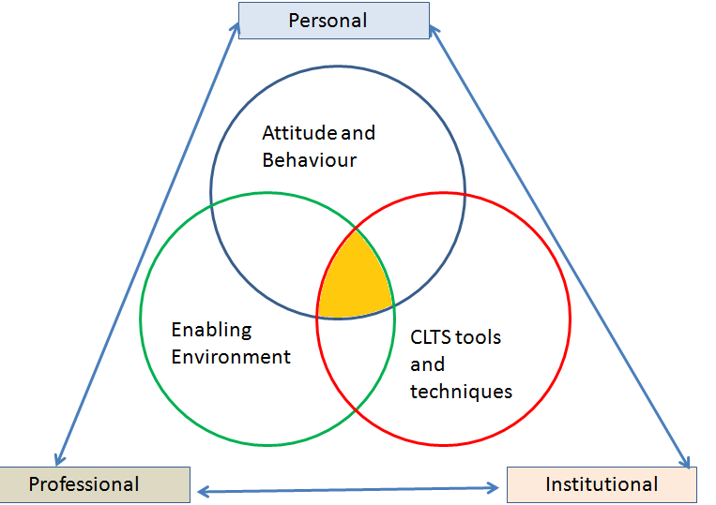

For CLTS to succeed, our personal attitude, professional attitude and our institutional attitude must change. In CLTS we need to consider as equals and we need to learn from the community sincerely. The success of CLTS depends on fine balance between three founding blocks viz: right Attitude and Behaviour, the enabling environment and effective administration of CLTS tools and techniques.

2.2: Dos and Don’ts
Such behavioural traits were understood through role-play. The trainees were divided into four groups and each one is given a separate assignment of non-verbal role-plays. The first group was assigned the role-play of Seriously Top down approach, Top down approach, Friendly approach and Participatory approach. These role-plays were analysed in the group and following riders emerged as Do’s and Don’ts for CLTS facilitation.

Dos | Don’ts
Greetings  Smiling  Inviting  Listening  Attending  Clapping  Accommodating  Mingle with people  Shaking hands  Waving hands in appreciation  Encouraging  Respect to local culture  Saying good bye before leaving the community | Dominate  Clear line of divide  Accompanied with assistant  No direct communication  Wagging hand to discourage people  Only one way instruction  No care to insiders observation  Lecturing  Finger Pointing  Showing cross hands to reject community opinion and ideas  Showing superior attitude  Making Angry Face  Dragging someone to meeting place  Ignoring the chief and elders  Communicating with chief or few persons  No attention to community members  Putting hands in pocket  Wearing tie, coats etc.  Carrying expensive bags in hand  Showing lot of paper and guidelines

Session III: Group formation and roles and responsibilities
Before closing, the participants were divided into working groups for the village triggering in coming days. The groups were a mix of people from different agencies as well as men and women.

The 6 groups gave themselves a name and villages were allocated for triggering

GROUP NAME | DAY 1 | DAY 2
OD Eradicators | Ha Sephoko | Ha Marumo
Cocozeb | Tumaole | Mahooana Khumbeboana
Mashai | Chejana
Mohale Sanitation Team | Tsekong | Khumbe/Soana
Likatola | Khupiso | Letsika
Phalafala | Sefatens | Likoanny

Facilitators explained the group roles and responsibilities and participants were left to think about those roles and how they would be divided. The roles were

Adult Group Facilitation Roles | Lead Facilitator  Co-facilitator  Content and process recorder  Environment Setter
Children's group Facilitation Roles | Lead facilitator  Co-facilitator  Environment setter  Facilitator for slogans / rhymes / procession

DAY 2: Friday, 14th November 2014
The day started with a brief recap of the day one. The highlights of the learning are that we are the learners and the communities are the teachers. It is important to recognise the fact that the attitude and behaviour of the facilitators are required a sea change rather than blaming the community’s attitude.

Session-IV: Technical Session: Stages and Tools of CLTS

4.1. CLTS: The Philosophy

CLTS operates on three key behavioural rules:
Rule I: Be nice to people
Rule II: Be nice to people
Rule III: Repeat rule I and rule ll

The assumptions under various such sanitation programme proved wrong. Such assumptions are like
- People are Illiterate – Teach them
- People are Incapable- Give them money/technology blue print
- People are ignorant- Prescribe
- People are Illogical- Convince them

However, CLTS makes a departure from the above assumptions and believes in People are capable and they can make change if collective analysis about their sanitation situation is facilitated well. Sanitation is a public good rather than an individual decision. Once community is enlightened through their own analysis, they will not wait for any body’s help and suggestion. They will initiate action based on their capacity and purchasing power. Such beginning will definitely lead to collective behaviour change, which has been the missing link in all other sanitation approach.

The key issue is not counting toilets but ODF communities; and we are not teaching but learning.

4.2: Stages of CLTS facilitation:
There are 4 steps in the CLTS process:
- Pre-triggering (1-2 days)
- Triggering (3-4 hours)
- Post triggering follow up (30 days to 3 months)
- Post ODF activities

Pre triggering
Pre-triggering involves establishing relationships between the facilitators and the target community to enter the community for triggering. Facilitator must go to the community, meet village leaders, and explain the purpose and objectives. Take a walk around and get an idea of the size of the village, population and any other sanitation programmes going on there (including subsidy). Find out a suitable date, time and place for the triggering so that it does not clash with market day or any other village event such as a wedding or funeral. You need to make more than one visit to the community to establish a good relationship.

Triggering is divided into part A and part B.

Triggering Part A: visual analysis by the community.
Part A is essentially involves the triggering tools
- Greetings,
- Climate setting,
- Explain objectives: you are here to learn, nothing to teach or give
- Explain the roles: you are here to learn and they are the teachers.
- Separate children from adults
[Above should only take 10-15 minutes]
- Defecation area mapping
- Emergency defecation mapping
- Shit calculation
- Calculation of medical expenses
- Defecation area transect walk
- Water and shit
- Food and shit
- Faecal-oral contamination route

Dry run of the tools through simulation exercises has helped the participants to understand the methods more particularly the application part of it. At the same time, using real life experiences from other places through video footages made demonstration of various tools. More emphasis was given on the typical gaps that are often noticed in many triggering exercises.

However, these are all tools, they are not an essential set of steps. Facilitators must use only what is appropriate to achieve triggering. Details of the tools and how to use them can be found in the Handbook on Community Led Total Sanitation by Kamal Kar with Robert Chambers that can be downloaded from www.cltsfoundation.org or www.communityledtotalsanitation.org.

If the community is triggered move to Part B. If community is not convinced to take action do not proceed mechanically. When some resistance is observed, using camera technique has been found quite effective in many places. Invite the community member to pose for a photograph and state that you are finding a village that are ready to continue eating their shit due to some reasons and you are going to put it in your report. In most of the case communities refuse to do so and it trigger further discussion towards some formative actions at their level. While application of tools is important, proper analysis and consensus building by using positive opinions from the participants are extremely critical.

Triggering Part B: Encouragement to continue and build platform for post-triggering
- Ask if they want to learn about low cost toilet from another community, and get them all to raise their hand if they do.
- Make a quick sketch of latrine to provoke discussion and encourage others to add to it
- Congratulate and applaud anyone who says they will start today
- Start a list on the wall of people, who are going to start today, then tomorrow, etc. Give much applause and encouragement.
- Tell them you will send a camera man the next day to film this. Ask what time he should come, take a phone number, etc, and make sure you send the camera.
- Before you go, leave paper and pens and suggest that they copy the map onto paper for a record and they can tick off the houses as they build their latrine
- Get them to set an exact date in the next 3 months so that you can come back with a camera and reporters to make a celebration of their ODF status.
- If they suggest they will not complete for 6 months or so, sound shocked that they will continue their practice of open defecation.
- Thank people before you leave.

All this has to be completed in 3-4 hours. So don't spend too long on introductions, or even on Part-A activities. You need at least 1 hour for part B.

Technical Session V: Presentation on CLTS including Global Experience
Kamal Kar gave a PowerPoint presentation giving glimpses of CLTS around the world. He began by saying that 2.6 billion people have no access to sanitation. More than a billion practice open defecation, thousands of truck loads of shit is being released. 42 children are dying every hour. There are dead bodies of toilets all around the world. These are toilets built by different agencies but that are not used. Sometimes hardware is diverted to other purposes like storage spaces, san plats used as a wall, concrete rings used as a feeding trough. In one village, three projects by three NGOs had brought three different styles of toilet. None were being used. This is called institutional open defecation.

There are also examples of good practice that come from CLTS. Wonderful varied designs of simple latrines made by local people from local materials. Once the behaviour is changed, people will then move up the sanitation ladder and make improvements to their latrines over time. Our purpose is to ensure that there is collective hygiene behaviour change.

Day 3: 15th December 2014, Saturday

Technical Session VI:

6.1: Developing group strategies for triggering exercises
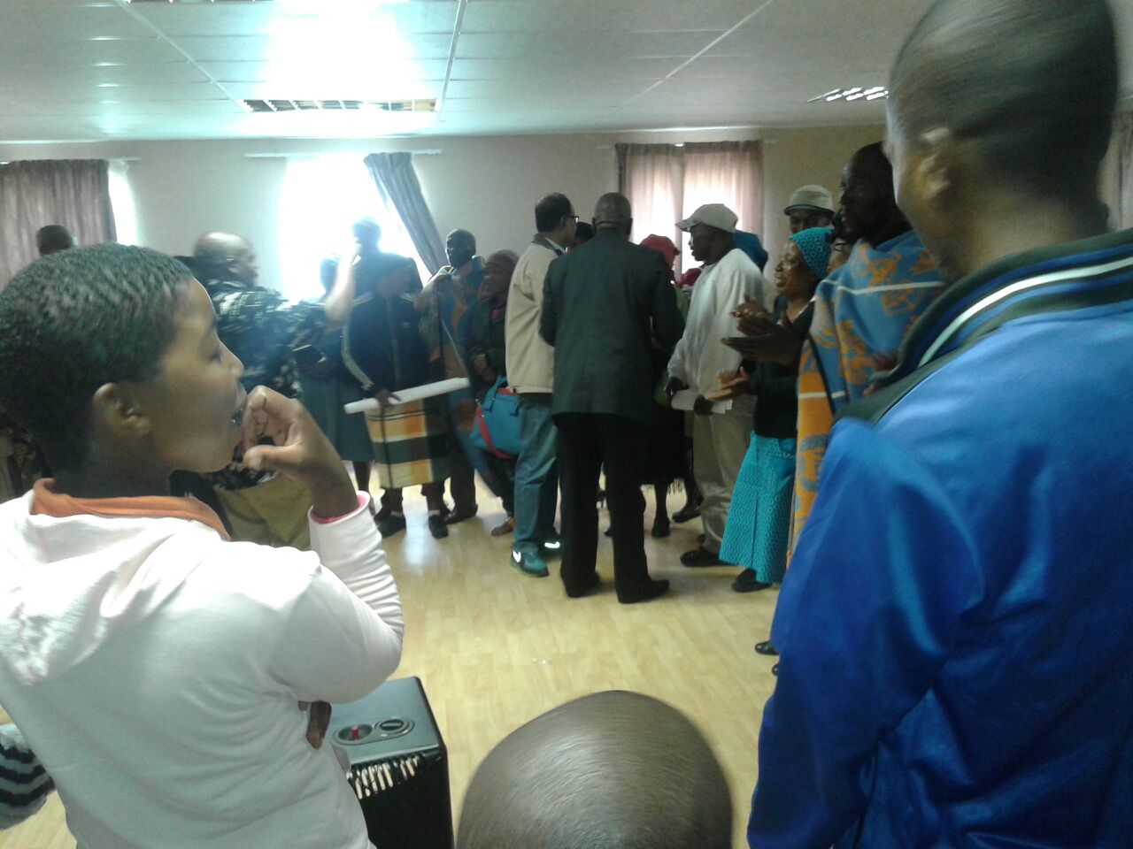
Groups were given time to prepare strategies for the next day’s triggering that include their team roles, decide which tools they would use, and prepare all the materials that they would take with them. Large group presentations of group strategies were made and gaps from presentations were analysed and groups were given more time to work on the gaps. As usual there are many groups who lacked in developing clear strategies for part B’ and special emphasis was given to explain about why it is important to give equal importance to both part A and Pat B. Unless teams give quality time and emphasis on part B, the community realisations through their own analysis cannot be converted to strong collective action which is key to the process.
Participants at the workshop

6.2: Triggering output analysis framework:
The facilitators also introduced the analysis framework of triggering tools that rests on different behavioural drivers. The various tools evoke different behavioural threads like, disgust, shame, fear, emotion and self respect which are critical for community empowerment and exert control by themselves.

DAY 4: 17th December 2014, Monday

Session VII: Practical Field Demonstration
The six groups went to their respective communities at around 8 am in the morning to ensure participation before people left to work in their fields. All groups had returned by 4.30 pm and soon after a brief classroom session on feedback resumed till late evening.

Feedback on morning triggering
Each group fed back on their experiences with the triggering according to a set of questions set out in the CLTS training guide. The key lessons to be taken into account for the following day were as follows:
- Overall the experiences of all groups were good. Some groups have really done well and created a good community enthusiasm and some have not done so well with mediocre success. Group coordination has been found to be most important aspect towards success and hence all the groups decided to reorganise themselves well for next day’s field triggering.
- If community members are standing around at the back and not participating then you can draw them into the groups and encourage them to participate.
- The person who is facilitating should not talk all the time. If people speak and say something interesting then invite them up and get them to speak. Hand over to them as much as possible. Let community members write, let them speak, let them act and mobilise others.
- If you manage to trigger the community with less tools you do not need to use them all and you can move on to part B. Only in this case we are practising using all the tools.
- It is important to stress that we do not bring anything in terms of resources. We have just come to learn not to give.
- People found that taking shit and bringing it to the triggering place is just an apprehension in outsider’s mind rather than a reality. It is not at all difficult to carry out food and shit demonstration and rather it has proven to be the most important tool.

A detailed group report of one of the successful triggering group has been attached as annexure 1 that outlines the detailed process carried out during the triggering exercise in Chejana village.

DAY 5: 18th November 2014, Tuesday

8: Session VIII: Practical field demonstration:

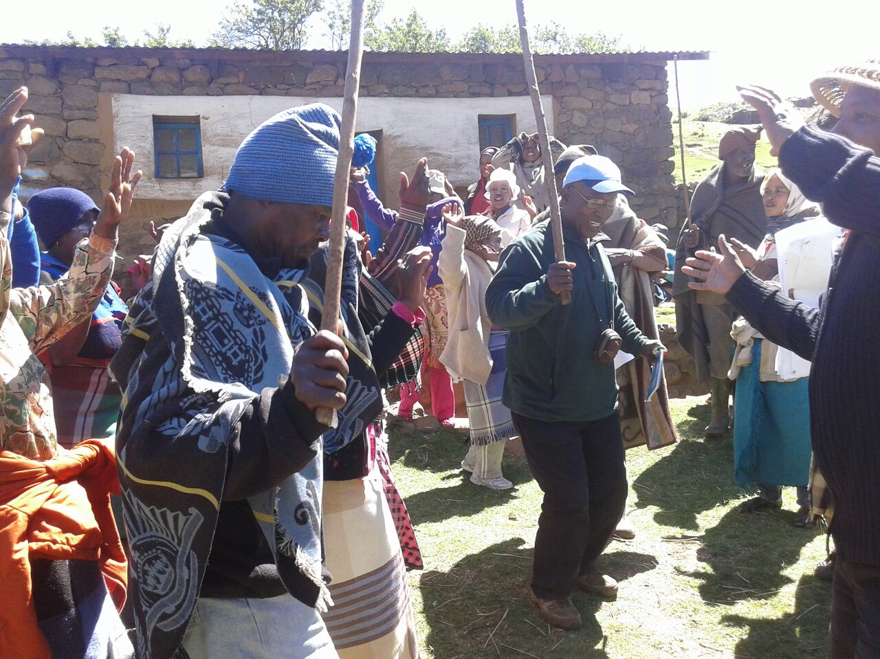
Once again, five groups went to their respective communities at around 6 in the morning to carry out triggering of CLTS. One group failed to go for the second days triggering due to the logistic issues and the organisers could not pretrigger any community for them to undertake triggering exercise. Hence the facilitators decided a second plan for them and Dr Kar coached the group on post triggering follow up and post ODF activities that they presented to the larger group in the evening. The Mashai group which failed to go to the community also developed a narrative of their group experience on first day’s field triggering to sharpen their understanding of the whole process. All the groups returned from the field in in the afternoon with a great success and almost all groups achieved resounding success in their triggering effort.
Participants at the field

9. Session IX: Feedback on morning triggering
Each group fed back on what had gone differently comparing the previous day with today. They were asked which went better and what the reasons were and why. The majority reported that the second day went better. The main factors raised were as follows:
- Groups felt better prepared and better organised as it was their second day.
- Team members were clearer on their roles.
- There was less domination by the lead facilitator, and all team members got to play a role.
- People who had not done training or triggering before had taken the lead roles and this had gone well.
- Groups had used all the triggering tools systematically rather than moving on to action planning once the community triggered.

10. Session X: Post triggering follow up and post ODF activities
The next session of the afternoon looked at post triggering follow up and post ODF activities. The Mashai group took a lead and presented the post triggering follow up action. Sisir and Dr Kamal Kar supplemented the group presentation with appropriate explanations and necessary knowledge inputs. The details can be found in the Handbook of Community Led Total Sanitation at www.cltsfoundation.org or www.communityledtotalsanitation.org.

10.1: Post triggering follow up actions:
- Talking to community members / natural leaders on the phone
- Follow up visit after a few days up to 2 weeks
- Monitoring Committee formation
- Monitoring map showing all the houses, and marking them off as they become ODF.
- Rules / fines developed by monitoring committee
- Continuing processions by children
- Children whistling as monitoring tool
- Exposure visits by natural leaders
- Demonstration to others of nicely made natural toilets
- Formation of ODF monitoring team (with government staff, natural leaders from other ODF villages, and others)
- ODF verification (3 stages: village level, district, regional)
- ODF celebration (invite a lot of people to encourage CLTS to spread

10.2: Post ODF Activities
- Natural Leaders as community consultants
- Declaring ODF District and Region
- Community Development activities by natural leaders
- Using natural leaders in other activities
- Rewarding CLTS champions
- Sanitation ladder
- Sanitation hardware market development
- Bringing visitors to ODF communities

11: DAY 6: 19th November 2014: Wednesday

Session XI: Preparation of action plans for next six months:

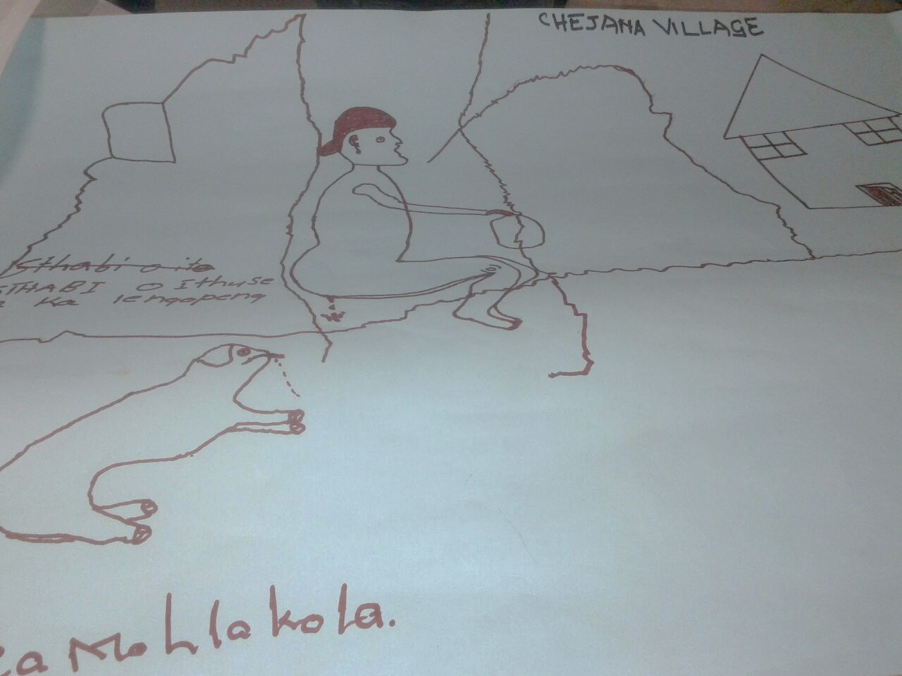
The participants organised themselves as district level teams involving the representatives from all the departments. The people from the central ministry and Maseru formed another group as a central coordination group. Lesotho Red Cross has also formed a group by themselves to develop their six monthly plans. All the groups developed a sketchy roadmap for themselves for the next six months that involved no of communities they would trigger, No of ODF communities they expected to achieve, number of trained human resources to be created and essential policy and coordination tasks to be taken up.
Children's impression of how OD is affecting their village

12: Session XII: communities presentation:

12.1: Natural Leaders' presentations
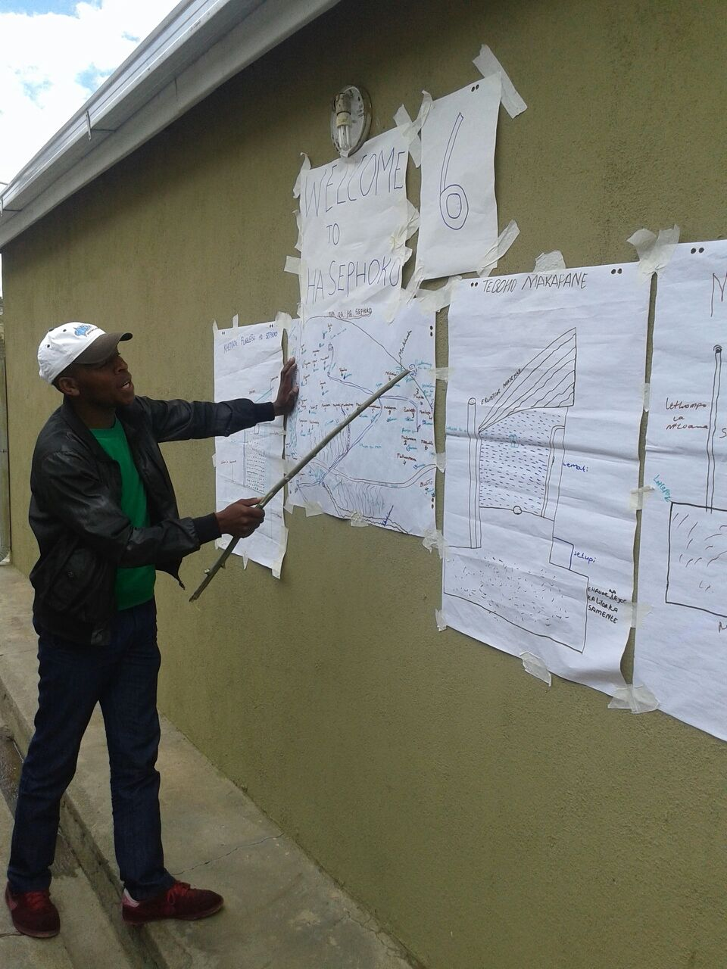
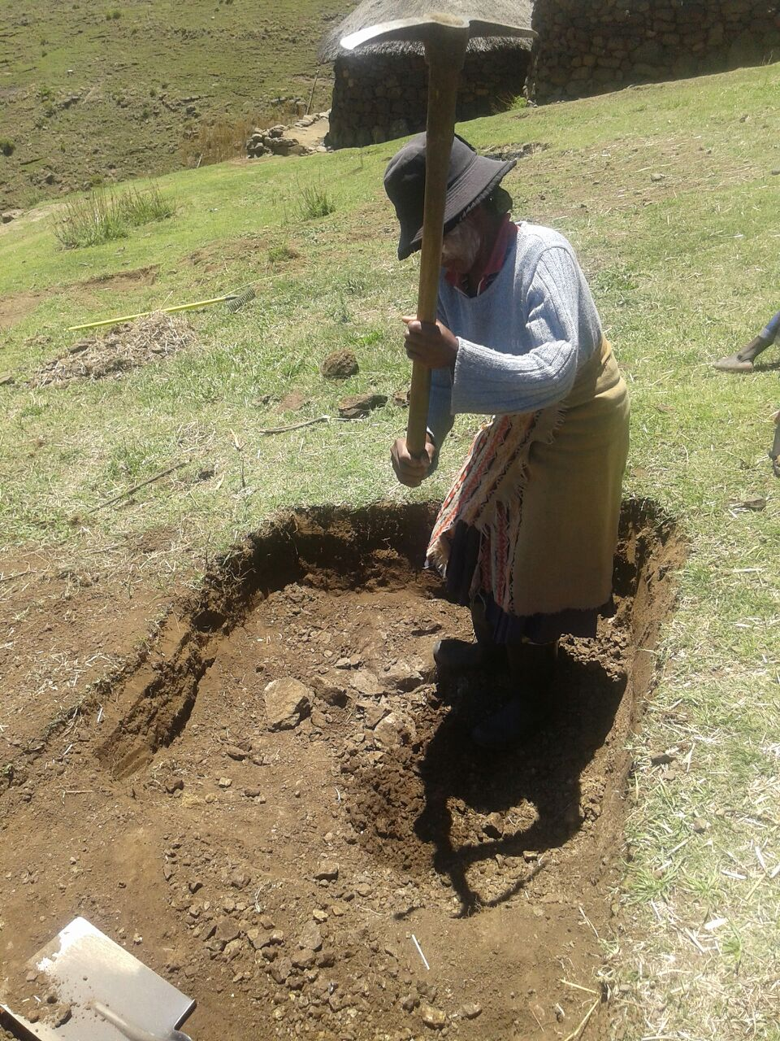
The late morning was spent welcoming Natural Leaders and helping them to prepare for their presentations. There were 11 stations posted outside the meeting hall where the Natural Leaders put up their posters including community maps, calculations done during the triggering, their action plans, and their date for achieving ODF status. It was heartening to see that within 24 hours of time almost 250 pits have been dug in those villages. Community representatives were visibly excited to present their success and they were very proud to tell their story of turning around their own village by themselves. Most of them in their presentation and opening speech reiterated their ability to control of their own life. Many of them admitted that issue is not money rather it is reaching out to the community in appropriate manner. They also clearly stated that till date many sanitation extension activities have been done but this has created greater community consensus and made them realise that they can solve their problem without much expenditure. Not only the participants, but also the representatives of local governance institutions have witnessed such wonderful community presentations. The local government authorities were so encouraged that they started dancing with joy by hearing the commitments and conviction of their fellow communities.
Woman digging pit in Tsekong village

The communities and participants got particularly excited when they saw the video clips of community action of digging lot of toilet pits in all triggered villages within 24 hours of collective community analysis of their own sanitation situation. All the community representatives have promised to declare their village ODF within 2 months time.

12.2: Comments by the local Government authorities: The representatives of the Local Government were asked to give their comment. They expressed great appreciation to the approach and community initiatives they witnessed though community presentations. At the same time they pledged all their support and monitoring inputs to all the villages triggered so far and expand such actions to many more communities in the region. They also promised to set a strong example for the entire country.
Presentations by Natural Leaders

12.3: Comments by Participants:
Few participants were also invited to give their comments on the workshop. The participants admitted that it is possible to achieve the result when communities are put in the centre of action and collective behaviour change inputs are given priority. The assumption they had about the community’s ability and resource poorness is wrong, rather collective action and social solidarity is key to achieving sanitation goals of the country. There surfaced their own professional gain and shift in thinking after going through these six days of experience.

Workshop evaluation
We revisited the objectives and all agreed that these had been achieved. Everybody was quite happy and convinced about the approach and methodology. They expressed their confidence in rolling out the same in their field locations. However, it was quite disappointing to observe that the entire district engineers had left the training before the concluding session. Their presence in community presentations and the concluding session would have been quite enriching for them and motivating for the district teams especially considering that the engineers are the key drivers in the district.

Key Observations and Conclusion:

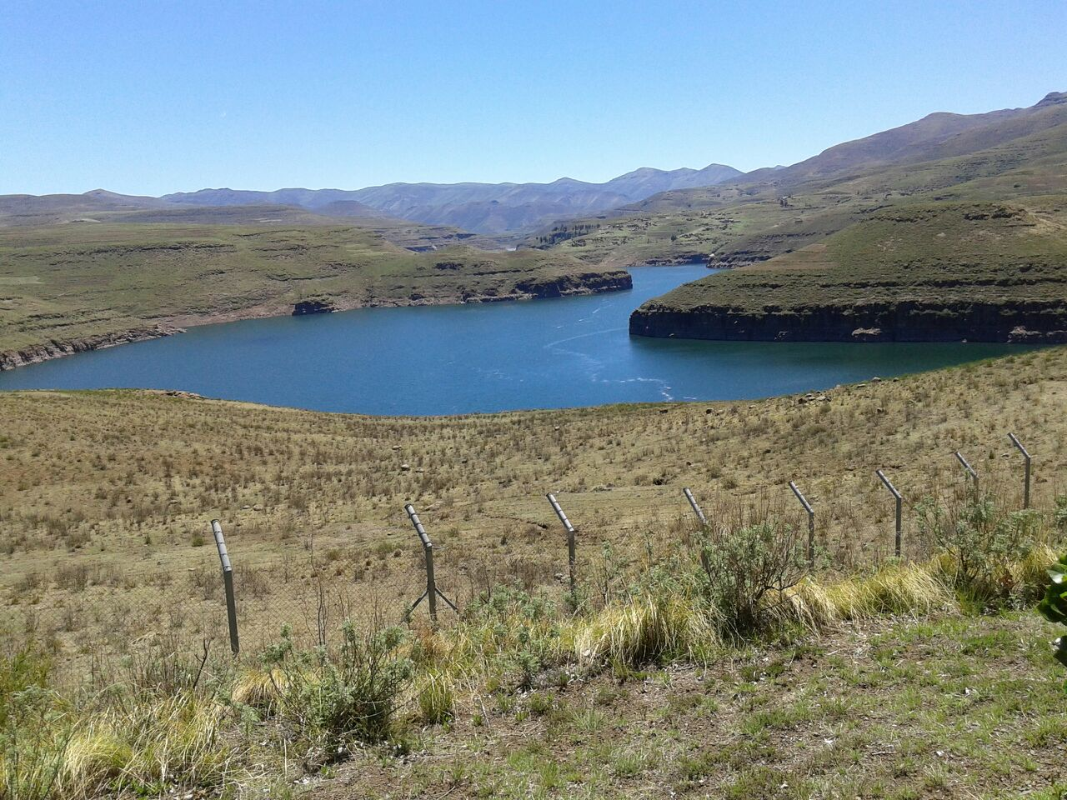
The workshop and particularly the district level participants exhibited a great interest and scope in rolling out CLTS as the key sanitation approach in the country. The state leadership also seems quite engaging with UNICEF, which will help in making the enabling environment suitable for CLTS implementation at scale. It is important to keep up the enthusiasm and momentum going by continuing the efforts of CLTS facilitation on the ground. Hence the suggested key immediate actions that requires to be taken up at the country level are as follows:

- It is critical to ensure the post triggering follow up action in the 11 communities, which were triggered during the hands on training workshop. UNICEF and Government of Lesotho may form a support team by pulling in people from various departments and organisations participated in the workshop and help the Thaba Tseka district team to declare these villages ODF in a quick timeframe.
- Plan for a ODF celebration by involving all the line departments, neighbouring communities and if possible political leaders of Lesotho. Such efforts will emit to create greater political-will, motivate the ODF communities to sustain the ODF status and replicate their efforts through peer exchange.
- Once these eleven villages are declared ODF use them as learning labs by inviting the natural leaders to other communities and also organise exposure visits to these communities.
- Organise one national workshop to discuss the learning and also carve out inter-institutional collaboration framework with clear capacity convergence agenda to upscale the CLTS intervention across the country. It is also important that the national government and all its departments should be brought to the same page and formulate a unified national CLTS strategy to minimise confusion and conflicts in the ground.
- Support and facilitate a study tour of relevant political and bureaucratic leadership of the country to another country where CLTS has been rolled out successfully. The neighbouring country Madagascar could be one such country to be considered for exposure visit.
- It is also important to document the process and capture the learnings of Lesotho’s path to ODF. Such documentation will provide for informed decision making and brining in both efficiency and effectiveness in the scaling up process of CLTS implementation.

