REPORT ON THE HANDS ON TRAINING WORKSHOP ON COMMUNITY LED TOTAL SANITATION IN CROSS RIVER AND BENUE STATE
OGOJA, CROSS RIVER STATE
12 – 17 JUNE 2014
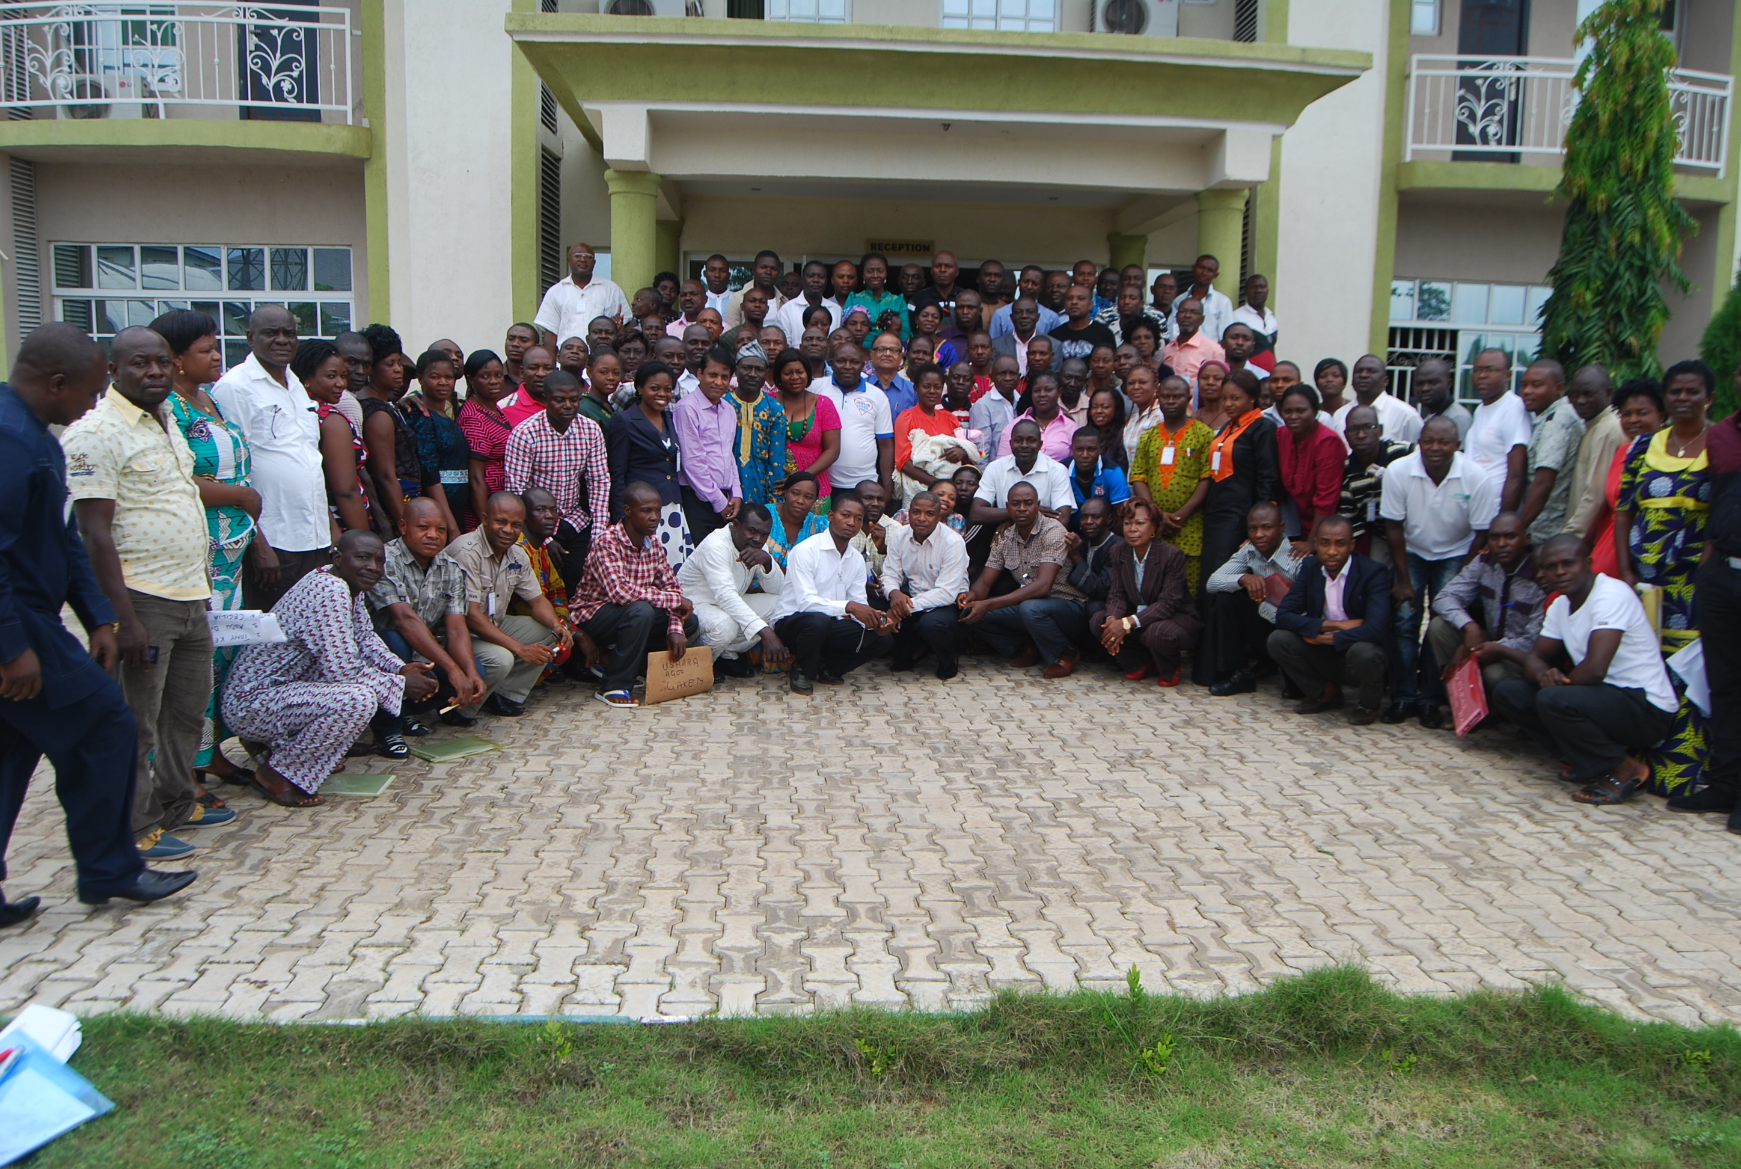

CLTS Foundation Global, CB -88, Salt Lake , Kolkata, India;www.cltsfoundation.org

Table of Contents
Background and Introduction 3
Inauguration 4
Participatory introduction and familiarising with the participants: 5
Session I: Mapping out Participants Expectations and setting the objectives of the workshop: 6
Presentation on the sanitation scenario in Cross River and Benue States 7
Technical Session 2: Why CLTS 7
Common reasons of failure 8
Key Lessons 8
Key Principles of CLTS 9
Technical Session III: Attitude and Behaviour Change/ Do’s and Don’ts 10
Dos and Don’ts 11
Technical session IV: Formation of Groups for field triggering and Roles and responsibilities. 12
Facilitation roles 13
Technical Session V: Global Overview of CLTS in practice: 13
Session VI: Triggering Tools for CLTS 14
Pre triggering 14
Triggering Part A: visual analysis by the community. 14
Triggering Part B: Encouragement to continue and build platform for post-triggering 15
Session VII: Post triggering analysis 16
Session VIII: Field Triggering Exercise 17
Session IX: Community Presentation 17
Session X: Comparative analysis of triggering experience of both the days: 18
Session XI: Post Triggering Follow up activities: 18
Session XII: Drawing up Action plan for next 6 months: 19
Session XIII: Participatory Evaluation of the training programme. 19
Conclusion 20

Background and Introduction

Rural Sanitation and Hygiene Programme in Nigeria (RUSHPIN) programme is being implemented in over 12 Local Government Agencies (LGAs) in Cross River and Benue State of Nigeria. CLTS Foundation on the request of Concern Universal, the executing agency of GSF has agreed to provide quality inputs and process support to the Programme. As a part of this collaboration, a training of trainer’s workshop was held in Ogoja from 12th to 17th June 2014 with the participation of 121 participants.

While majority of the participants were from LGAs WASH teams, a sizable number of participants were also from the state RUASSAs, Civil Society Organisations (CSOs), Executing Agency technical support team from both the states. In addition two Natural Leaders from both the states also joined the group.

Inauguration

The training workshop was inaugurated on 12th June 2013 with a welcome note by Mr. Nanpet Chuktu, programme manager of RUSHPIN, key note address by Ms. Clara Rudholm, Programme Manager of GSF and an opening remark by Dr. Eben Eba of RUWASSA, Benue state.

While Mr. Nanpet stated the purpose of the training programme, Ms. Clara gave an account on the GSF perspective and reiterated the importance of RUSHPIN programme to `demonstrate an effective scaling up mechanism for CLTS implementation to achieve two ODF states in particular and ODF Nigeria in general which houses the largest number of open defecators in Africa. Dr. Eben Eba in his inaugural address mentioned about the commitment of the state and appreciated the RUSHPIN team for organizing the training programme in the initial days of the programme implementation.

Participatory introduction and familiarising with the participants:

A participatory introduction session was facilitated where in each participant met with several co-learners and tried to know each other better. The participants shared information such as their name, place of birth, place of work, marital status, number of kids, professional experience etc. This exercise was useful in revealing some critical information with regard to the profile of the participants.
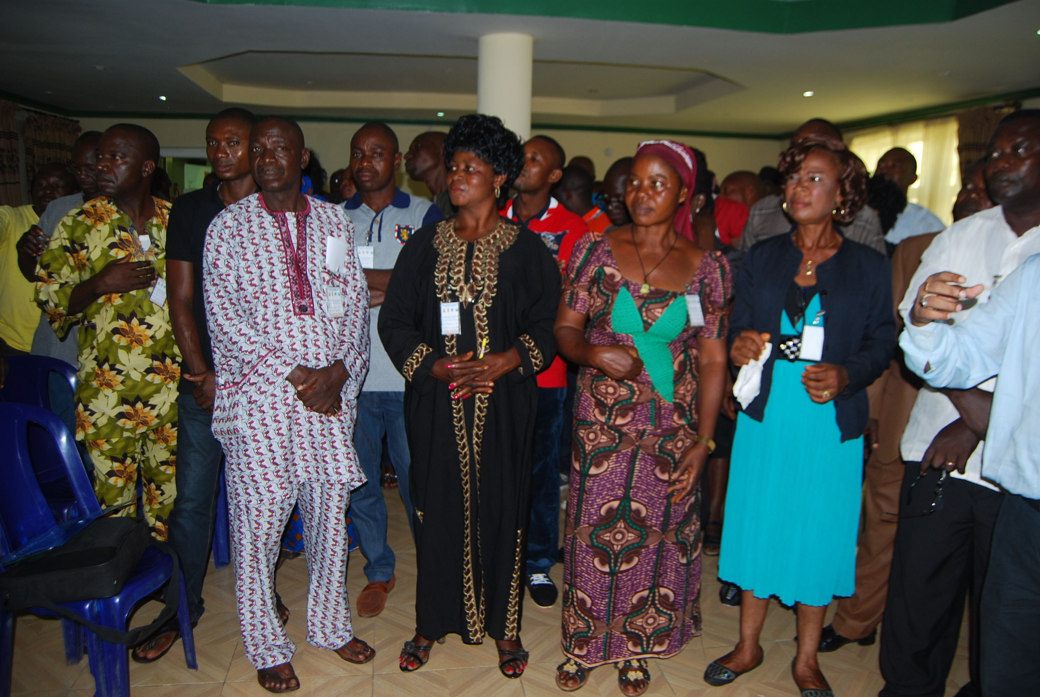
Figure 1: Particpants from workshop

As far as the male and female composition of participants is concerned, the number of male participants was quite high with 73 participants. At the same time the participation of women was also substantial

Session I: Mapping out Participants Expectations and setting the objectives of the workshop:
Participants were asked to come up with their expectations through group discussions. Participants came up with number of expectations that were clubbed under 10 thematic lines that are given below.
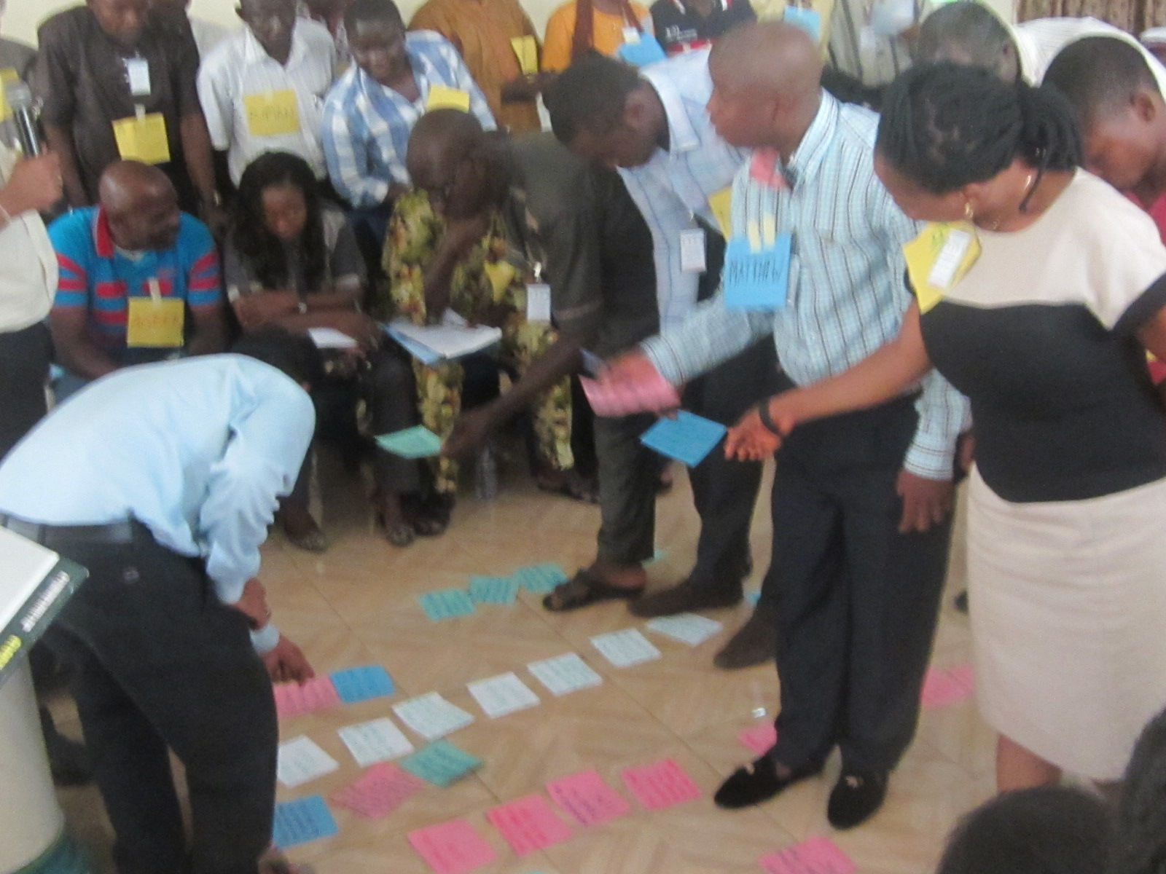
- CLTS Tools and Techniques
- Knowledge of CLTS
- CLTS Facilitation Skills
- Elements of Training of Trainers
- Scaling up of CLTS
- What is Collective behavior change
- Advocacy and Institutional Collaboration
- Knowledge and Experience Sharing
Figure 2: Participants mapping out their expectations
- Monitoring & Evaluation of CLTS
- Technology and improvement in sanitation ladder

The expectations were matched with following objectives through floor interactions and discussions. All the participants unanimously accepted and agreed to objectives of the training workshop.
OBJECTIVES:
By the end of the five days ‘hands-on’ training workshop all participants will have

- Gained clear understanding and knowledge on the principles, rationale, methodology, applicability and limitations of Community Led Total Sanitation (CLTS) with special reference to Cross River and Benue state in Nigeria.

- Gained and strengthened skills of facilitating CLTS triggering with rural communities

- Explored potential options of scaling up CLTS across 6 LGAs of Cross River and Benue to expedite CLTS implementation and achieve ODF status in an incremental rate with a clear emphasis on engaging with Natural leaders and community consultants

- Reviewed the present practice of CLTS on the ground in different LGAs of Cross river and Benue state and improve CLTS implementation by developing a post triggering follow up strategy

- Sharpened training skills in order to render quality training to the facilitators and future trainers of CLTS across the regions

- Shared experiences of triggered communities as outcome of triggering carried out during the workshop

- Developed institutional/organisation plans of action to scale up CLTS in all the 12 LGAs in the next 6 months, with a vision of saturating all 6 LGAs of two states by 2016.

Presentation on the sanitation scenario in Cross River and Benue States
Soon after 1st technical session Mr. Nanpet made a brief presentation on the present status of CLTS implementation in Cross River and Benue state with specific reference to the RUSHPIN programme intervention. A brief account of progress of RUSHPIN programme helped the participants to understand the present scenario and task to be accomplished in the next three years.

Technical Session 2: Why CLTS
To garner understanding of ‘why CLTS?’, the participants were divided into five groups and asked to reflect and brainstorm on past projects on sanitation that had failed, and to analyse the reasons why they had failed. These were then shared back in the larger group and key lessons were drawn out from the sharing exercise. The following table synthesizes the outputs of the group work.
Group name | Name of the project | Year of Implementation | Reasons of failure
Gr 3 | Sanitation intervention using subsidy approach by UNICEF | 2003 | No follow-up by Government  Hijacked by influential citizens  Lack of sustainability  Inability by the community to provide counterpart fund  Lack of adequate sensitization
Gr 1 | Establishment of sanitation centres in the community by Government and UNICEF | 2002-2005 | No accountability for sales of the ‘SanPlat’  Communities complained of high cost of SanPlats  No means of transporting SanPlat from LGAs to communities  Government driven  No ownership  Poor monitoring
Gr 3 | Integrated Rural Water Supply and sanitation (Irish and French Embassy project | 2004-2005 | Poor budgetary allocation  No innovation  Not community driven  Lack of monitoring
Gr 3 | Sanicentre management, UNICEF | 2004-05 | Inadequate community mobilization  Provision of Subsidy  Lack of attitudinal change  Lack of community participation
Gr 4 | RUWASA and CLTS  UNICEF Borehole  UUNIESS Water Project | 2008-2010 | Lack of funds  Political diversion  Lack of staffs to operate pumping machine
Gr 5 | SANPIPLAT | 1996- 2002 | Community not involved in planning  It was not community driven/subsidy driven  High cost of production  It was political driven  Technology was friendly  Mismanagement of funds  Poor monitoring plan and follow up  Lack of political support and sponsorship
Gr 6 | National Environmental Sanitation Programme | 1984 | It was not people oriented  Unstable Government policy  The fears and intimidation of force.

Based on the above observations, the participants identified some common reasons for failure.

Common reasons for failure
- Community was not allowed to participate in the decision-making
- Imposition of external ideas and solution
- Huge outside subsidy and considering latrine as a solution
- Latrine design is imposed by outsiders
- Target for household construction
- Lack of sensitization and focus on behavioural change
- Most of the projects are supply driven, not demand driven
- Higher donor dependency
- Lack of clear understanding and follow-up

Key Lessons
The key lessons from this session were as follows:
- Need to shift from infrastructure approaches to outcomes and behaviour change
- Need to shift from external teaching approach to learning from the community
- Change in professional attitude is important.
- Both action and approach needs to be participatory

The assumptions under various such sanitation programmes proved wrong. Such assumptions are like

- People are Illiterate – Teach them
- People are Incapable- Give them money/technology blue print
- People are ignorant- Prescribe
- People are Illogical- Convince them

Based on these failures the CLTS approach emerges. It is about confinement of human excreta safely so that it does not emit health hazard. The focus is not on latrines but on human beings.

Key Principles of CLTS
The key principles of CLTS that explains the departure from other sanitation approach are as follows:
- CLTS is “Total’’ and involves all
- It fosters and relies on collective community decision
- Social solidarity and cooperation
- Locally decided and not dependent on external subsidies and prescriptions or pressures.
- Natural leaders emerge from collective local actions
- Doesn't follow externally determined mode of development
- Allows local diversity

CLTS is an approach which triggers four key elements of human behaviour i.e. element of disgust, element of shame, element of fear and element of self-respect.

Technical Session III: Attitude and Behaviour Change/ Do’s and Don’ts Behaviour and attitude changes of outsiders are essential for the successful facilitation of CLTS. CLTS operation on three key behavioral rules i.e.
Rule I: Be nice to people
Rule II: Be nice to people
Rule III: Repeat rule I and rule ll

However there has been a strong bias that exists in all three spheres, which include Personal, Professional and Institutional biases. There is a perceived relation of ‘uppers and lowers’ that exists in the society among different actors. Some examples of such biases are
Professional attitudes – Doctors are favoured over Teachers
Institutional attitudes – World Bank is favoured over NGOs
Personal attitudes – Men are favoured over Women
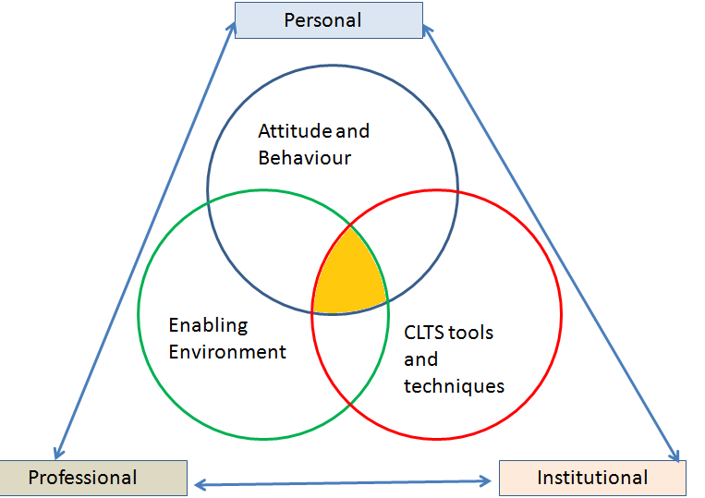

For CLTS to succeed, our personal attitude, professional attitude and our institutional attitude must change. In CLTS we need to consider each other as equals and we need to learn from the community sincerely. The success of CLTS depends on fine balance between three founding blocks: Right Attitude and Behaviour, An enabling environment and Effective administration of CLTS tools and techniques.

Dos and Don’ts
Such behavioural traits were understood through the role-play exercise. The trainees were divided into four groups and each one was given a separate assignment of non-verbal role-plays. The first group was assigned the role-play of Seriously Top down approach, the second one was assigned the Top down approach, third the Friendly approach and the fourth group was given the Participatory approach. These role-plays were analyzed in the group and following riders emerged as Do’s and Don’ts for CLTS facilitation.

Dos | Don’ts
Greetings  Smiling  Inviting  Listening  Attending  clapping  Accommodating  Mingle with people  Shaking hands  Waving hands  Encouraging  Respect to local culture  Saying good bye before leaving the community | Dominate  Wagging hand to discourage people  Only one way instruction  No care to insiders observation  Lecturing  Finger Pointing  Showing superior attitude  Making Angry Face  Line of divide from Community  Dragging someone to meeting place  Drinking water (carried from outside)  Ignoring the chief and elders  Communicating with chief or few persons  No attention to community members  Putting hands in pocket  Wearing tie, coats etc.  Carrying expensive bags in hand  Showing lot of paper and guidelines

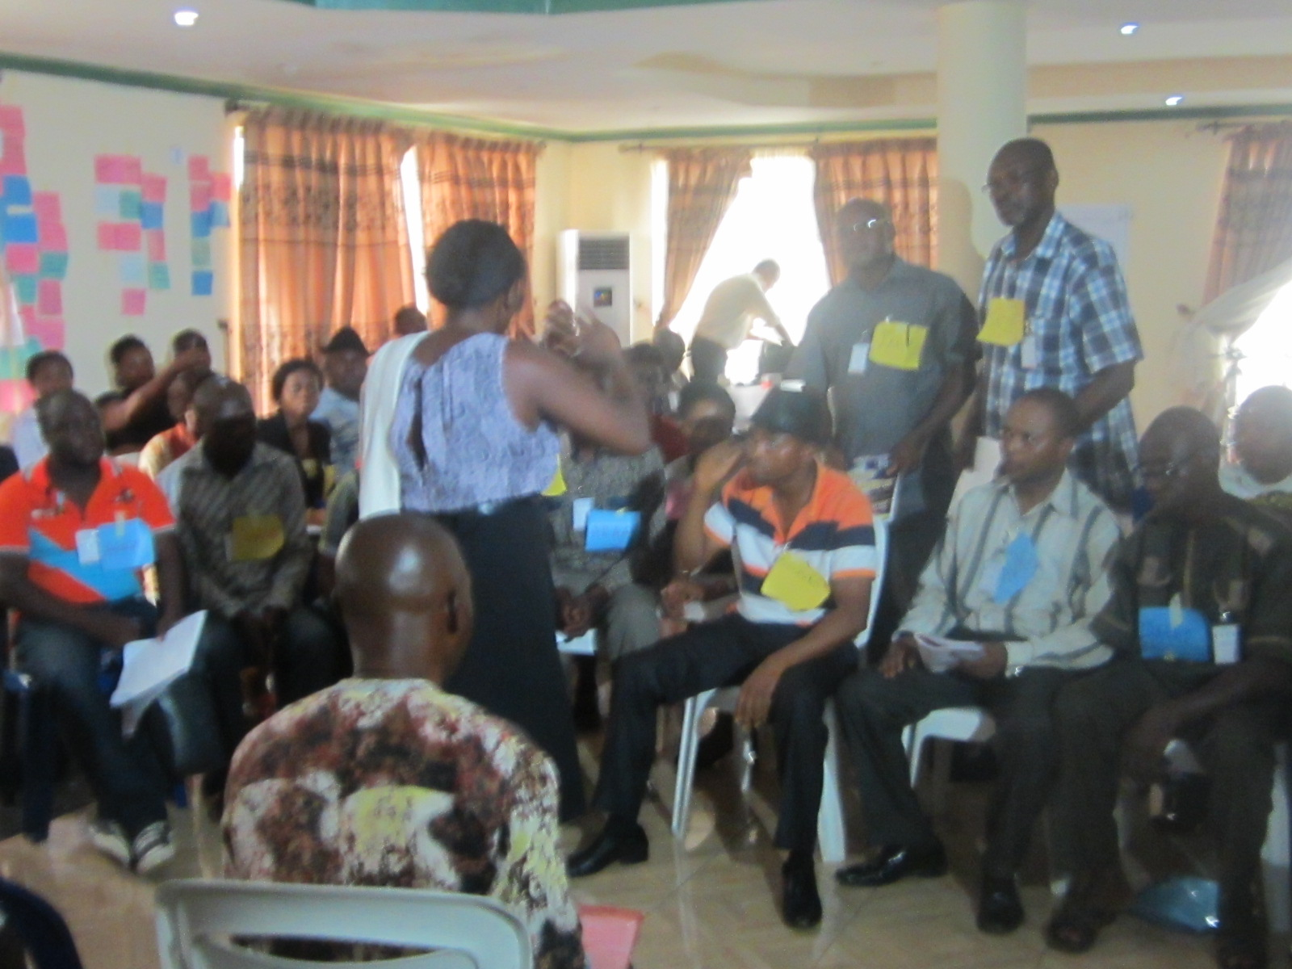
Figure 3: Enthusiastic participants discussing
The day ended with the exercise of Do’s and Don’ts in CLTS facilitation.
DAY 2:

Technical session IV: Formation of Groups for field triggering and Roles and responsibilities.
After a small recap session of the previous day’s input, ten groups were formed for field triggering, considering the number of participants. While forming the groups care was taken that each group has equal number of participants, women members and they are well represented by all the institutions. Each group was asked to give good name and write down the name of the members of the respective groups in one column of a chart paper. The groups for field triggering for hands-on practice are given below.
Sl No | Name of the Group | Name of the community (day 1) | Name of the community (day2)
1 | Flush Group | Ayogoba Atibulum | Iniye Ukan
2 | Tosan Group | Ichiakpo | Utiang Atiambi
3 | Clean Up Group | Adachiye | Eya Aten
4 | Orange Group | Agbrigbatibulum | Agbara
5 | Shit Customers Group | Ushara Ishane | Abukpem II
6 | Royal Shit Group | Ushara Ago | Ikweduno Adachi
7 | Abong Group | Inyie Okan Irishi Okpashu | Betukwer Atiambi
8 | Shit Masters Group | Ikwu Ukwere Ushara | Asharaba Iruhuwue
9 | Change Group | Ushara Irishi Alibi | Adiowow Akuruny
10 | Apple Group | Anyung Atibulum | Inyiye Alibi

Facilitation roles
After the group formation the facilitators described the roles and responsibilities and participants were left to think about those roles and how they would be divided. The roles were

Adult Group Facilitation Roles | Lead Facilitator  Co-facilitator  Content and process recorder  Environment Setter
Children's group Facilitation Roles | Lead facilitator  Co-facilitator  Environment setter  Facilitator for slogans / rhymes / procession

Basic qualities and pre-requisites for each role were explained and demonstrated on the floor to prepare the participants to form their group roles.

Technical Session V: Global Overview of CLTS in practice:
In spite of technical hiccups, Dr Kamal Kar made a thought provoking presentation of the present sanitation practice across the globe taking few live examples from countries around the world. It was clearly evident that the predominant mindset is that of standardized, subsidised toilet. People are poor; they don’t know and hence give them toilets and teach them hygiene behaviour. As a result, there have been thousands of abandoned toilets and relics and dead bodies of toilets.

Through various examples from across various parts of Asia, Latin America and Africa, it was explained that CLTS is successful; it relies on local decisions and does not depend on external forces and prescriptions. Natural Leaders emerge during the process of CLTS facilitation. The facilitating organization’s job is not to produce toilets, rather to develop Natural Leaders. Children also play a great role in monitoring and conveying the CLTS message. Local diversity and innovation are key to the CLTS approach. When triggering tools are used, the community immediately realises the faecal-oral contamination process. They see that the food is being contaminated by shit which is then going into their mouths and stomachs. . The external facilitator’s job is to facilitate in such a way that this message is communicated properly and community will learn from their own analysis. When they are doing the self-analysis, they are questioning themselves as well. Such process gives rise to local wisdom, innovations and mechanism to address their own problem.

Session VI: Triggering tools for CLTS
Considering the fact the participants had some degree of exposure in CLTS triggering, the major emphasis was on analyzing gaps in facilitation and plugging in such gaps having gained knowledge on desired practices.
Mr. Sisir Pradhan introduced all the four stages of CLTS facilitation into this session. They were as follows:
- Pre-triggering (1-2 days)
- Triggering (3-4 hours)
- Post triggering follow up (30 days to 3 months)
- Post ODF activities

Pre triggering
Pre-triggering involves establishing relationships for the facilitator to enter the community for triggering. The facilitator should go to the community, meet village leaders, and explain his/her purpose and objectives. The activities involved at this stage would include: Taking a walk around and getting an idea of the size of the village, population and any other sanitation programme going on there (including subsidy); Finding out a suitable date, time and place for the triggering so that it does not clash with market day or any other village event such as a wedding or funeral. One may need to make more than one visit to the community to establish a good relationship.

During the pre-triggering discussions, the need for wider and clear communication was emphasized through a participatory game (whispering and one to one transmission of message).

Triggering is divided into part A and part B.

Triggering Part A: visual analysis by the community.
- Greetings
- Climate setting
- Explain objectives: we are here to learn, nothing to teach or give
- Explain the roles: we are here to learn and they are the teachers.
- Separate children from adults
- Defecation area mapping
- Emergency defecation mapping
- Shit calculation
- Calculation of medical expenses
- Defecation area transect walk
- Water and shit demonstration
- Food and shit demonstration
- Fecal-oral contamination route demonstration

These are all tools; they are not any essential set of steps. Use only what is appropriate to achieve triggering. Details of the tools and how to use them can be found in the Handbook on Community-Led Total Sanitation which can be downloaded from www.cltsfoundation.org.

If the community is triggered, then move to Part B.

If they are not interested then you must just leave. But before leaving the facilitator must use another effective tool and request the community to take a photograph and humbly convey that, you have seen a village that is ready to continue eating their own shit and put the picture in the report. Do not be tempted to start teaching if they are not responding. An experienced facilitator will just walk to the vehicle and the community will then call them back as we are dealing with human beings.

Triggering Part B: Encouragement to continue and build platform for post-triggering
- Ask if they want to learn about low-cost toilet from another community, and get them all to raise their hand if they do.
- Make a quick sketch of a latrine to provoke discussion and encourage others to add to it
- Congratulate and applaud anyone who says they will start today
- Start making a list of people and paste it on the wall , of those who are going to start today, then tomorrow, etc. Give much applause and encouragement.
- Tell them you will send a cameraman the next day to film this. Ask what time he should come, take a phone number, etc. and make sure you send the camera/cameraman as you promised.
- Before you go, leave paper and pens and suggest that they copy the map onto the paper for a record and they can tick off the houses as they build their latrine
- Get them to set an exact date in the next 3 months so that you can come back with a camera and reporters to make a celebration of their ODF status.
- If they suggest they will not complete for 3 months or so, sound shocked that they will continue their practice of open defecation.
- Thank the people before you leave.

A great degree of emphasis was laid to highlight the gaps that were observed from the pre training review of practice visit to the four LGAs. Clifford made a pictorial presentation of various gaps observed during the field visit. Dr Kar also analyzed different gaps with the help of pictures taken during the field visit in the previous week. This session was quite useful to make the participants aware about the existing wrong practices and various corrective measures to overcome such gaps. Soon after the classroom analysis, the facilitators through role-plays also demonstrated few tools as preparation for the next day’s triggering exercise.

Before the close of day, the groups were asked to divide various facilitation roles between different team members and also to draw a plan for the next day’s triggering keeping in mind both part A and Part B of the triggering exercise.

Day 3:
The ten groups went to their respective communities at around 7.30 am in the morning to ensure participation before people left to work in their fields. The facilitators also visited about eight villages to observe the process on ground. All groups had returned by 1.00pm and the participants reassembled in the training hall to prepare for sharing of their experiences.
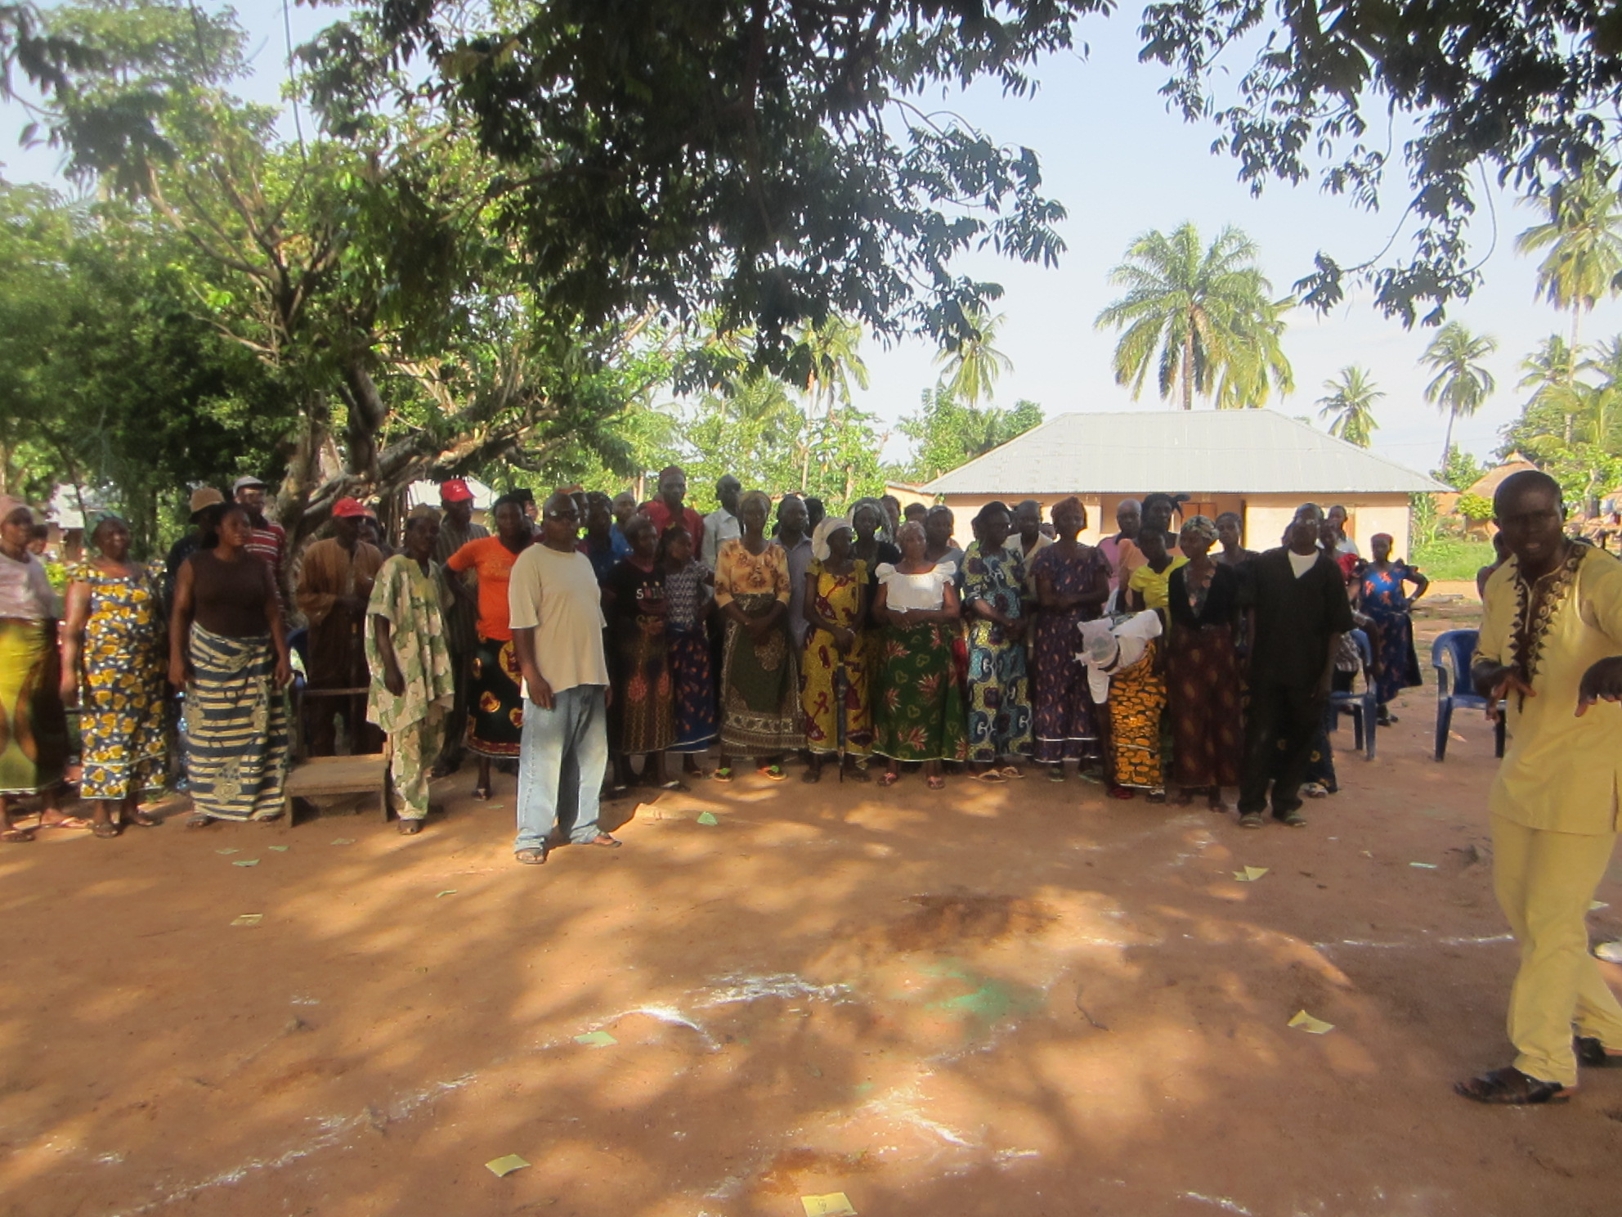
Figure 4: In the field

Session VII: Post triggering analysis
Each group was asked to present their learning and what went well and what went wrong. During the post lunch session the sharing was done.

From the group sharing a series of common mistakes and field challenges were identified such as:

- Climate setting was not properly done
- In many groups climate setters were the passive on lookers and did not perform their roles appropriately.
- No proper coordination between team members
- Confusing the roles of members
- Quickly shifting the discussion to toilets. There was no shit calculation in many groups.
- Few tools were used by many groups. Except two groups no one did shit calculation, medical expenses calculation etc.
- In many groups, there was no use of water-shit and food and shit demonstration.
- Transect walk-in done with only two to four persons and they were taken away from the beginning of the triggering exercise.
- Missing out of the aspects of identifying community engineer and encouraging them to share their ideas.
- Heavy lecturing
- In many groups the co-facilitator was not very accurate
- In few groups the child-triggering process was not proper and it failed to bring out the emotional trigger that was required.

By using video footage of the field triggering taken from the field, facilitators explained the gaps and corrective measures. While explaining the effectiveness of the triggering participants were briefed about various triggering outcomes which are given below:

- Best outcome: Match box at Gas station
- Second best outcome: Promising Flame
- Third level of outcome: Scattered spark
- Fourth outcome: Damp matchbox

All the participants were asked to analyze their triggering activities in reference to the above mentioned outcomes and effectiveness of tools with regard to various triggers like disgust, shame, fear, emotion and self-respect. Such field observations and deeper analysis of them provided enough impetus to participants to rethink and re-strategize their group actions to achieve better outcome in the next day’s triggering.

Day 4:

Session VIII: Field Triggering Exercise
The group triggered another set of ten villages. The challenges before the group were even bigger. Some of these communities are transitional villages having semi-urban characteristics. However, banking on the previous day’s feedback, participants did very well.

Day 5:

Session IX: Community Presentation
The day 3 started with the arrival of the community Natural Leaders to share their priorities, ideas and thoughts after being triggered on Day 3. Keeping in mind the logistics challenges, only the communities triggered on day 1 of the field practice were invited to present. There were 10 stations posted under the tent erected outside the training hall, where the Natural Leaders put up their posters including community maps, calculations done during the triggering, their action plans, and a committed date for achieving ODF status etc.

Following a brief welcome and explanation of proceedings in the hall the presentations by Natural Leaders began at around 10.00am. Groups of around 8 to 10 participants moved from station to station having the opportunity to listen to around 8 presentations of 5 to 10 minutes each. Besides the participants, the representative of Ogoja LGA and state consultant of UNICEF joined the presentation.
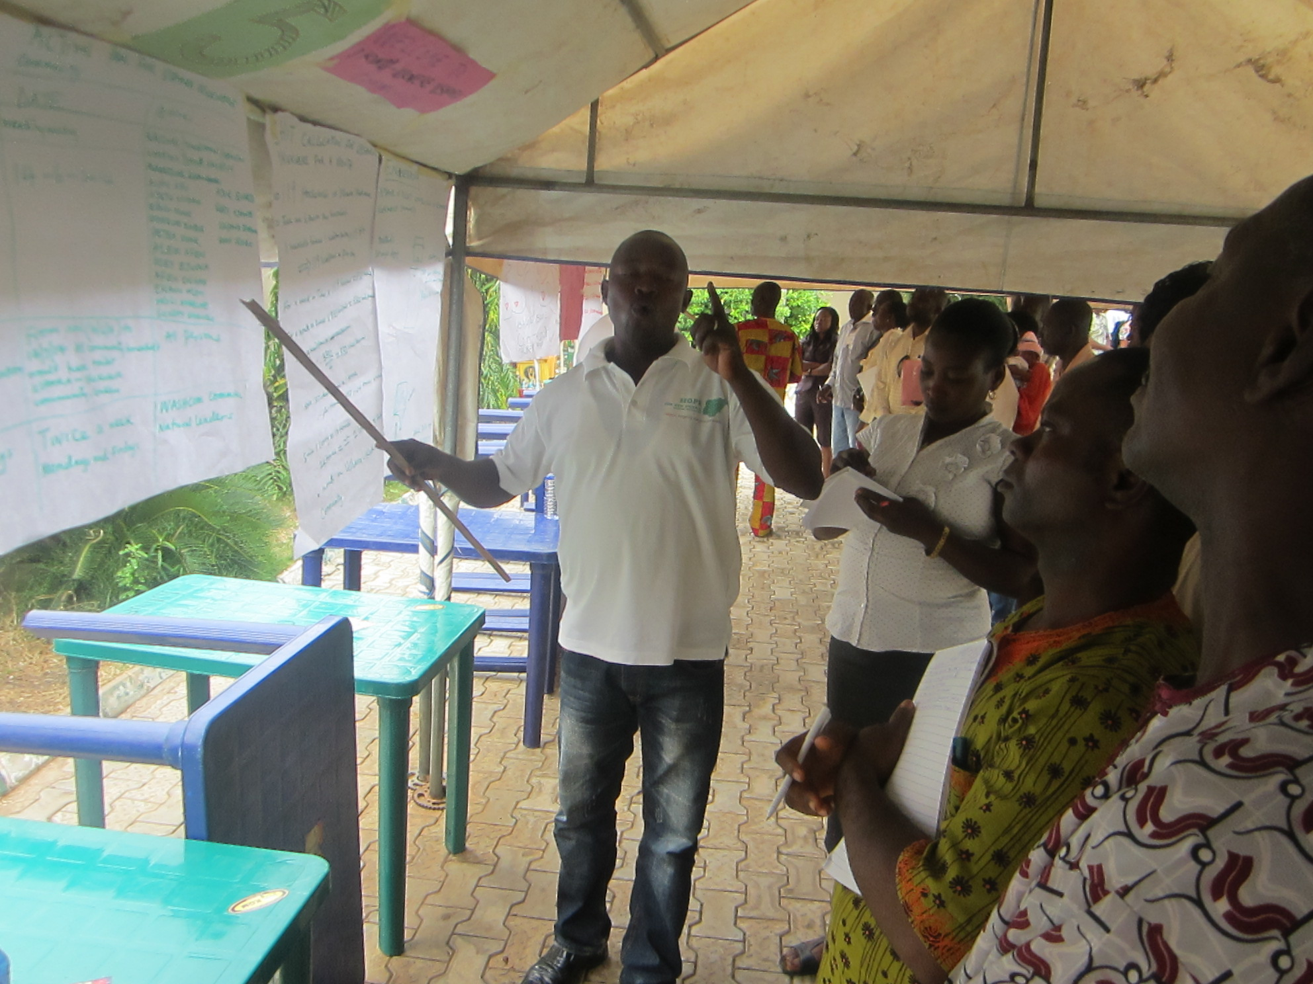
Figure 5:presentation by Natural Leaders
Soon after the visit of community stalls, everyone gathered in the training hall. The Natural Leaders were invited to speak on the occasion and as many as nine Natural Leaders came forward and spoke quite convincingly about their experience and determination of making their village ODF. Almost all revealed that they are going to declare their village ODF within one month time. It was quite encouraging and voices of Natural Leaders were quite bold and powerful.

Session X: Comparative analysis of triggering experience of both the days:
Participants were requested to make a very brief one-minute presentation of each group on the differences and improvement they have noticed in their triggering exercise by using the same framework i.e. analysis of tools with respect to different triggers like disgust, shame, fear, emotion and self-respect. The facilitators and other observers also shared some gaps that still persisted like sizes of maps, process of transect walk, formation of WashCom, improper application of tools etc.

Session XI: Post Triggering Follow up activities:
From the review of practice visit it was quite evident that the understanding of post triggering follow has been quite poor among the facilitators. Hence a lot of emphasis was on bringing clarity on the rationale of each activity that would make the follow-up effective and help the community to monitor their own process for greater accountability and sustainability of ODF. The typical post-triggering activities discussed are as follows:
- Visit to triggered communities within two to three days from the date of triggering.
- Display the monitoring map showing all houses in a central location and engage the Natural Leaders to mark them off as they become ODF
- Talk to community members / Natural Leaders on the phone
- Visit the individual houses with Natural Leaders and encourage everyone.
- Demonstration to others of nicely made natural toilets
- Organise on the spot (preferably near a toilet by using that as an example) discussions of ODF criteria with Natural Leaders and the community members
- Continue with children’s activities like processions, slogans, songs etc.
- Facilitating community level institutional mechanism like Rules / fines developed by monitoring committee.
- Continue identifying Natural Leaders who will evolve from the ODF process.
- Formation of village sanitation committee (WASHCOM)
- Organize exposure visits of Natural Leaders and community members (from low performing communities to visit high performing communities)
- Formation of ODF monitoring team (with government staff, natural leaders from other ODF villages, and others)
- ODF verification (3 stages: village level, district, regional)
- ODF celebration (invite a lot of people to encourage CLTS to spread)

The day was closed with a take-home assignment to all the LGA wise teams to develop a plan for next 6 months.

Day 6:

Session XII: Drawing up Action plan for next 6 months:
The last day of the training workshop began with developing LGA wise road map for the next six months. The participants from various LGAS were asked to produce a plan through group discussions among the respective team members from different LGAs on the key parameters viz, number of ODF villages to be produced, number of ODF clans to be produced and number of Natural Leaders to be identified and nurtured and their plans to share the learning with their colleagues. Few LGAs have given concrete plans by dividing the entire LGS into different zones and assigning responsibilities to sub-teams for each zone with a clear target of triggering, ODF communities and the number of Natural Leaders. Few LGAs were still sketchy in their planning and they were asked to revise their plan based on realistic assessments and to re-submit them to the Executing Agency and CLTS Foundation for further inputs.

Session XIII: Participatory Evaluation of the training programme.
Finally the facilitator with the help of scoring and some lead questions facilitated a participatory evaluation of the training programme. Before the scoring, the facilitator asked the participants to compare the last six day’s learning with the training objectives and the expectations from the programme as expressed during the first day of the training programme. Each participant seemed to be convinced that the workshop could meet his or her expectations to a large extent. The table given below is a reflection of the participants’ opinions on various aspects i.e. the key to continue good work in their workspace after returning from the training programme.

Key questions | Number of participants arranging themselves according to different score level (higher score indicates higher level of satisfaction and accomplishment
 | 20%-40% | 40%-60% | 60%-80% | Above 80%
How far have the expectation been met from the workshop? |  | 10 | 37 | 27
Will the learnings derived from the workshop be useful? |  |  | 23 | 44
How confident do you feel to train others? |  | 1 | 7 | 69
How do you rate your institutional environment? | 10 | 51 | 8 | 8

Here it is important to note that significant work needs to be done on the last criteria i.e. improving the institutional environment for achieving desired results on the ground.

Conclusion
The workshop has created a lot of enthusiasm among the training participants. There is a lot of promise as the group has good number of efficient and effective facilitators. The community also offers a good environment for quick results on ground. RUSHPIN programme has not only got the edge of achieving great success of producing ODF communities within a short timeframe, it can also pave the way for new strategies, approaches and elements of CLTS implementation as well as bring about far fetching impact on community life and livelihoods. A strong follow-up support - both financial as well as hand-holding support is required to keep up the momentum and also to ensure progress as per the envisaged plan. At the same time it is quite important to undo various wrong practices and create an enabling environment to overcome challenges on hand such as the following:

There is a prevalent mindset of sticking to the old practice. It has been observed that there is a strong tendency of ignoring the new knowledge inputs. The prevalent practice is very much tool-focused (in fact without exploiting the potential of each tool) rather than focusing on outcomes. Such elements needs to closely monitored, discouraged and corrective measures must be taken.

There is no proper understanding of the concept on Natural Leaders. Ten natural leaders were invited into the training programme and only two of them were from ODF villages. Hence the RUSHPIN programme must bring in place a uniform criterion of natural leaders as the persons who have taken initiative and succeeded in their efforts to make their own village ODF and have also shown promise to influence the neighboring villages.

RUSHPIN programme must monitor the quality of triggering by analyzing application of tools with respect to different behavioural traits as explained earlier, outcomes by maintaining healthy ratio between triggered & ODF villages and also the larger health and economic impact at the community level.

While there are some challenges in hand, the training workshop could develop a lot of field level capacities. The level of motivation and encouragements seen among the LGA team and Executing Agency is quite encouraging as well. A strong follow up, handholding and institutional collaborations will definitely produce faster and positive outcomes in the region.

