

**REPUBLIC OF NAMIBIA**

**CLTS ASSESSMENT REPORT IN FOUR REGIONS OF NAMIBIA**

**8TH OCTOBER TO 2ND NOVEMBER, 2016**

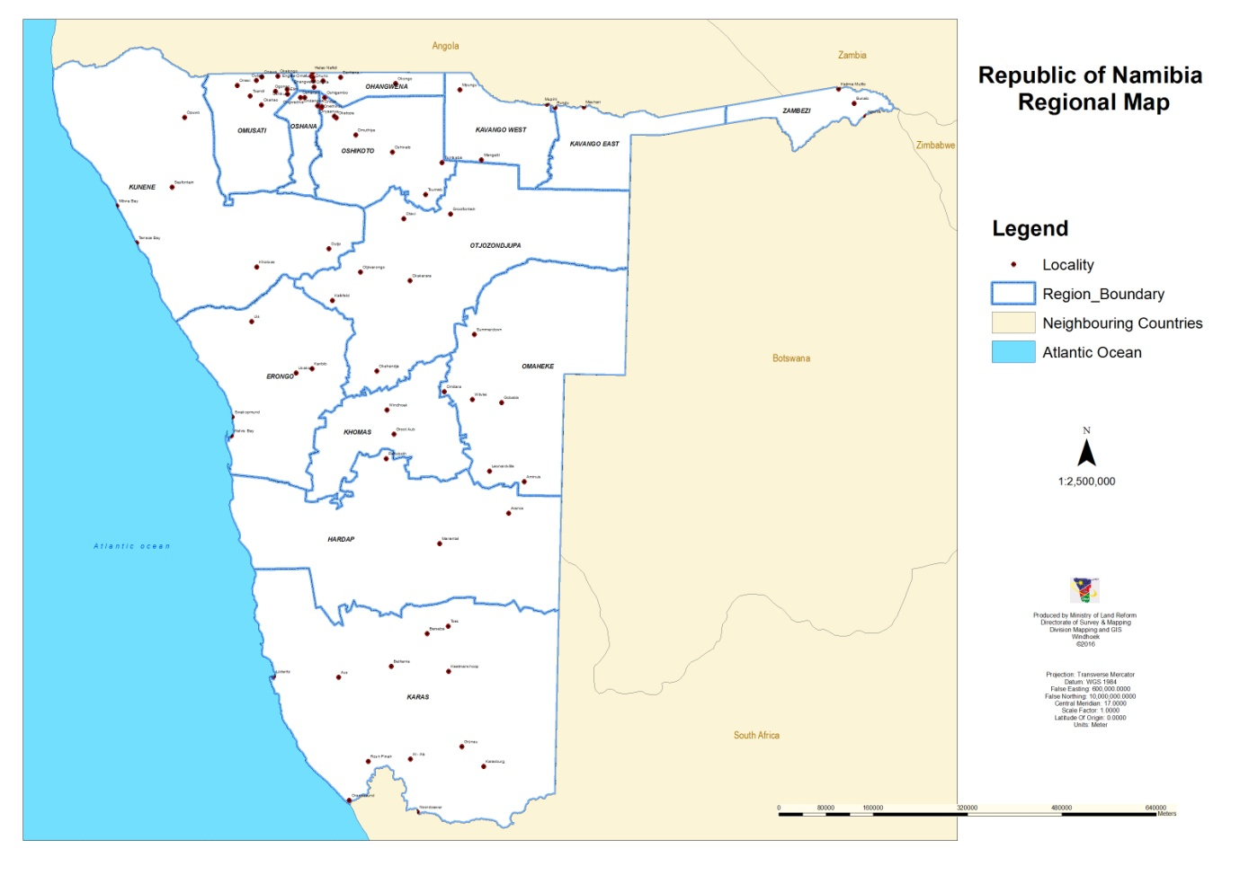

LEONARD MUKOSHA

CLTS Consultant,

Email : [humilitylcm@yahoo.com](mailto:humilitylcm@yahoo.com)

Mobile : +260 977 103 271.

15/11/16.

**TABLE OF CONTENTS**

**ABBREVIATIONS**

1. INTRODUCTION
2. NATIONAL CONSULTATIVE MEETINGS
3. ZAMBEZI REGION
4. KAVANGO EAST.
5. KAVANGO WEST.
6. OHANGWENA REGION.
7. KEY FINDINGS AND CHALLENGES
8. RECOMMENDATIONS
9. CONCLUSION

|  |  |
| --- | --- |
| ACRONMYS. |  |
| CC | Community Champion |
| CLTS | Community Led Total Sanitation. |
| CDC | Constituency Development Coordination. |
| CBO | Community Based Organization. |
| DWSSC | Directorate of Water and Sanitation Coordination. |
| LA | Local Authority. |
| LADC | Local Authority Development Committee. |
| LC | Local Contractor. |
| LM | Line Ministry. |
| MAWF | Ministry of Agriculture Water and Forestry. |
| ME | Ministry of Education. |
| MoHSS | Ministry of Health and Social Services. |
| NDP4 | National Development Plan 4. |
| NSS | National Sanitation Strategy. |
| OD | Open Defecation. |
| ODF | Open Defecation Free. |
| ODFN | Open Defecation Free Namibia. |
| RC | Regional Council. |
| RCC | Regional Council Coordination. |
| SAG | Sanitation Action Group. |
| SAREP | South African Region Environmental Project. |
| WATSAN | Water Supply and Sanitation. |

**FIELD TEAM**

|  |  |  |  |  |
| --- | --- | --- | --- | --- |
| **S/N** | **NAME** | **POSITION** | **MOBILE NUMBER** | **E-MAIL ADDRESS** |
| 1 | MR.J. Kasheeta. | Director MURD | +264811412626 | jkasheeta@murd.gov.na |
| 2 | Doctor Jean Kaseya | Chief child survival and development-UNICEF | +264612046206 | jkaseya@unicef.org |
| 3 | Leonard Mukosha | CLTS Consultant | +260977103271 | humilitylcm@yahoo.com |
| 4 | Matheus Shuuya | WASHE Specialist | +264811474408 | mshuuya@unicef.org |
|  |  |  |  |  |

**INTRODUCTION**

Community Led Total Sanitation was introduced in Namibia by SAREP (South African Region Environmental Project) a Botswana based NGO with Funding Support from USAID. The first training was conducted from 27th May to 1st June 2013 in Collaboration with Integrated Rural Development and Natural Conservation (IRDNC) and The Ministry of Agriculture Water and Forestry (MAWF). At that time 30 Participants from Government Line Ministries and Community Based Organizations were trained including 15 participants from the lead ministry – MAWF, Directorate of Water Supply and Sanitation. The training took place in Zambezi region, 10 Villages where triggered in two Constituencies of Katima Rural and Sibbinda.

The Second Training was conducted in April 2014 followed by a Third training in September 2014. Under UNICEF Support, Namibia Red Cross also conducted a fourth CLTS training from 31st August to 8th September 2015 in Eehana, Ohangwena region targeting 5 villages. So far a total of 140 CLTS Trainers of Trainers have been trained and 44 Villages triggered during these TOTs. It is against this back ground that Progress view was conducted in the named four regions to:

1. Review Progress of CLTS in the Four Regions.
2. Consider Achievements and Challenges Faced.
3. Draw Lessons Learnt and Way forward.
4. Inform Pilot Project Design in two constituencies of Kavango West and Ohangwena.

**NATIONAL & REGIONAL CONSULTATIVE MEETINGS**

**MINISTRY OF URBAN & RURAL DEVELOPMENT (MURD)**

The Program started with consultative meetings at national and regional level involving key stakeholders and other sanitation actors. On Monday 10th October 2016 a Meeting was held with the Directorate of Urban & Rural Development at The Ministry of Urban and Rural Development (MURD). This is the ministry responsible for construction of fully subsidized VIP Latrines in the communities worth N$ 35,000 each. Under the Harambee Prosperity Plan (HPP), 50 000 Latrines are scheduled to be constructed over a period of 4 years. The Ministry indicated that:

* Sanitation as a routine activity has No Funding allocation.
* There are No Developed Plans for Sanitation at National Level.
* Although Sanitation is not Funded, Government has through the Ministry of Finance so far sourced some money to support the HPP.
* Sourced Funds amount to N$30 million.
* Already N$18 million has been disbursed to 9 regions:
* Zambezi Region.
* Kavango West.
* Kavango East.
* Ohangwena.
* Oshikoto.
* Omusati.
* Oshana.
* Kunene.
* Distribution of these Funds will move to cover all the regions.

**MINISTRY OF AGRICULTURE WATER AND FORESTRY (MAWF)**

On Tuesday 11th October 2016, another National level consultative meeting was held at the ministry of agriculture and forestry with the directorate of water supply and sanitation. This is the lead ministry for sanitation established under the Water Supply and Sanitation Policy of October 2008.

Equally at this ministry:

* Sanitation has no funding allocation.
* Sanitation Plans are not there.
* The ministry has also been constructing Latrines under the subsidy arrangement.
* There is no database for sanitation at the ministry.

The Ministry highlighted some of the key interventions that should be undertaken in order to improve the sanitation situation:

* Awareness Creation.
* Strengthening the WATSAN Forum.
* Conduct base line survey on sanitation.
* Open Defecation Free Campaigns.
* Cabinet Decision needed to set target for ODF Namibia and work towards the same target.
* Formation of ODF Task Force and CLTS Champions from Line Ministries.

**MINISTRY OF EDUCATION ( MoE)**

On Wednesday, 12/10/16 a meeting was held at Education. The Director for Quality Assurance indicated that they have a memorandum of understanding with the ministry of health and social services to promote hygiene education in schools which includes hand washing. They also have a school health task force in place while on the other hand UNICEF is supporting WASH in schools. Sanitation in schools in the northern regions is very poor as one out of five schools do not have latrines ( 20% ).

**MINISTRY OF HEALTH AND SOCIAL SERVICES (MoHSS)**

These are the custodians of Public Health. Under the Water Supply and Sanitation Policy ( WASP) of 1993 MoHSS was responsible for Sanitation up to 2008 when the said policy was replaced in 2008. Hygiene Promotion however still remains the mandate of MoHSS. Unfortunately we did not meet with the ministry as all the directors were out in the field during the time under review.

**REGIONAL MEETINGS AND FIELD WORK: THURSDAY 13th – 24TH OCTOBER 2016**

Regional Meetings went on very well with all the regional councils, Line Ministries and the two Governors for Zambezi and Kavango East. The Governors offered to work as CLTS Champions in their respective regions. Details for each region are covered below.

**ZAMBEZI REGION (POP: 96,639)**

**CONSTITUENCY MAP**

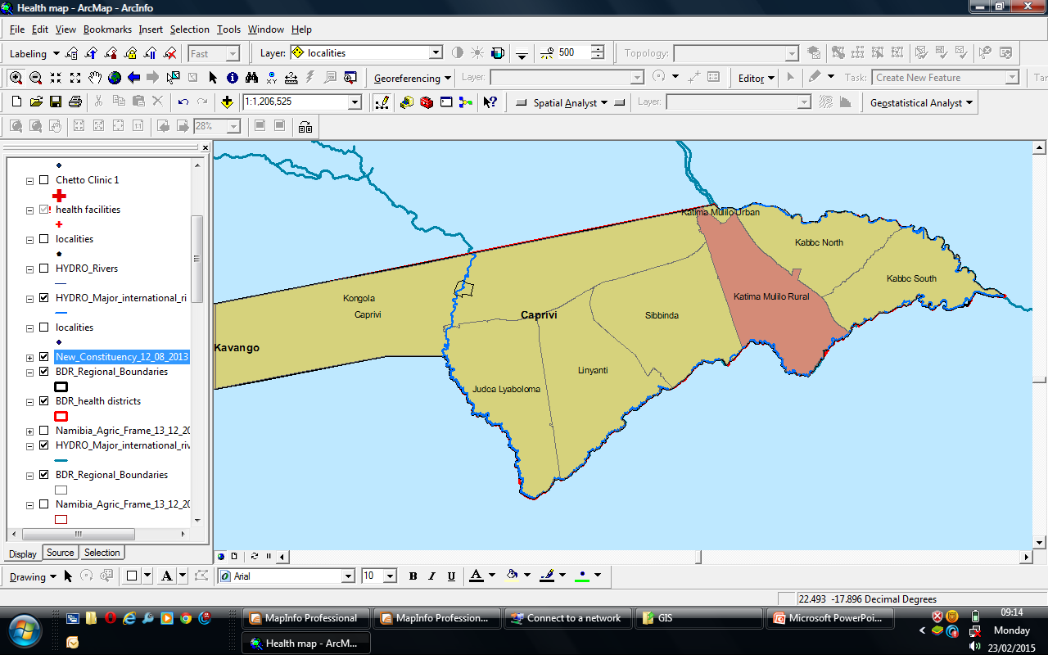

|  |  |
| --- | --- |
| **CONSTITUENCY** | **NUMBER OF VILLAGES/LOCATIONS** |
| 1. Sibbinda | 28 |
| 2. Judea Lyaboloma | 253 |
| 3. Kabbe South | 267 |
| 4. Kabbe North | 127 |
| 5. Katima Rural | 747 |
| 6. Kongola | 29 |
| 7. Linyanti | 72 |
| 8. Katima Urban | TBA |

**STAKEHOLDERS AND RESPONSIBILITIES**

|  |  |
| --- | --- |
| **STAKEHOLDER** | **RESPONSIBILITY** |
| 1. Ministry of Agriculture, Water and Forestry | Lead Ministry, Coordination |
| 2. Ministry of Rural Urban & Urban Dev. | Latrine Construction |
| 3. Ministry of Education | School Sanitation and Hygiene |
| 4. Ministry of Health | Hygiene promotion in schools |
| 5. Katima Mulilo Town Council | Urban Sanitation and Hygiene. |

**MEETING WITH MAWF**

On Thursday 13/10/16, a meeting was held with Acting Regional Director Ms Betty Muyatwa and her staff from The Ministry of Agriculture Water and Forestry. The team indicated that:

1. Zambezi has a total of 8 Constituencies:
2. Katima Rural Constituency.
3. Katima Urban
4. Sibbinda.
5. Lyabboloma.
6. Kongola.
7. Kabbe North and
8. Kabbe South.
9. A total of 30 CLTS trainers of trainers were trained by SAREP from 27th May to 1st June 2013. Out of this number 13 came from The Ministry of Agriculture Water and Forestry.
10. The team triggered 12 Villages in two constituencies of Katima Rural and Sibbinda.
11. Villages Triggered:
12. Mafuta in Katima Rural Constituency.
13. Sachinga in Sibbinda Constituency.
14. Sabelo
15. Sipilisa.
16. Sitanta
17. Lwabanze.
18. Mapilelo.
19. Mukutulo.
20. Muzauli.
21. Sepa sahao
22. Mukusi.
23. Likunganelo .
24. After triggering the above villages no follow-ups where made and Sanitation Action Groups were not formed.
25. In 2014 The Ministry of Agriculture Water and Forestry Constructed 108 VIP Latrines at a cost of N$35,000 each in the same Villages where CLTS was triggered in Katima Rural Constituency thereby Killing the CLTS Program.
26. The MAWF has no Sanitation Budget or Program at that level and work in isolation.

**MEETING WITH GOVERNOR FOR ZAMBEZI**

***(Governor Lawrence Sampofu, Dr. Kaseya, Mr. Shuuya and Mr. Mukosha. The Governor Pledged his availability to be used as CLTS Champion for Zambezi Region )***

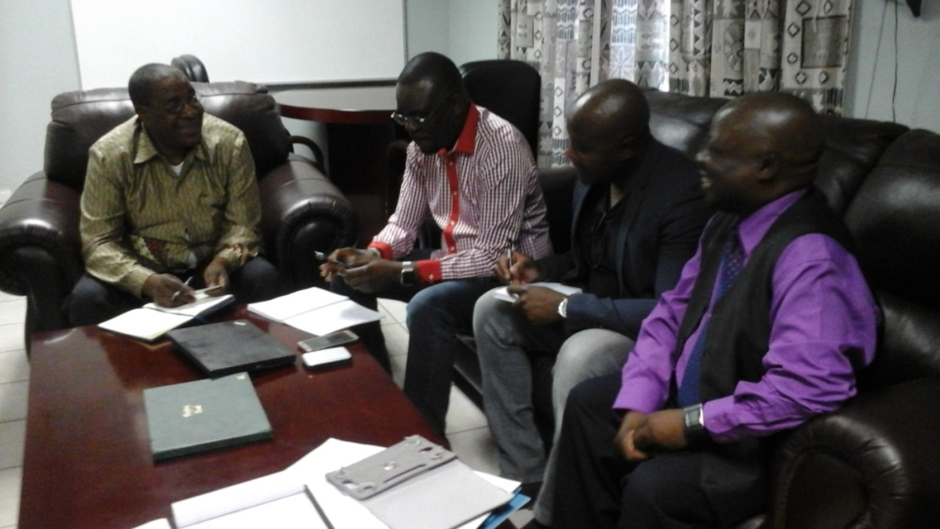

In the afternoon on Thursday we had another stakeholder meeting with Ministry of Health and Social Services staff. Zambezi Health has 28 Rural Health centres with 200 Health Extension Staff who are on Government Pay roll and work at community Level. The Health Extension Staff report at the clinic. This is a rich human resource that CLTS could utilize as they work with communities. Each Health Extension Worker is assigned to 1OO Households for the Purpose of Hygiene Promotion and treatment of minor conditions. Each Health Facility has an average of 5 – 10 Health Extension Workers.

**DISTRIBUTION OF HEALTH EXTENSION WORKERS IN CONSTITUENCIES:**

|  |  |  |
| --- | --- | --- |
| **S/N** | **CONSTITUENCY** | **HEWS** |
| 1 | Kongola | 27 |
| 2 | Katima Mulilo | 46 |
| 3 | Kabbe | 32 |
| 4 | Sibbinda | 31 |
| 5 | Linyanti | 19 |
| 6 | Lyabboloma | 20 |
| 7 | Kabbe South | 25 |
|  | **TOTAL** | **200** |

The Staff at regional Level indicated that they have not been involved in CLTS activities. Although Partners such as Red Cross, DAPP exist they only meet in emergencies such as Floods. There is no platform for sanitation and a common plan to follow. The Ministry focuses on Hygiene Promotion in Schools and Communities.

After a courtesy call on The Regional Governor for Zambezi Col. Hon. Lawrence Sampofu a meeting was held with the Regional Council, this was on Friday 14th October 2016. Key Findings from that meeting where as stated below:

* There is no Sanitation Plan at regional Level.
* Funding allocation for Sanitation is not available apart from the subsidy arrangement.
* Coordination Lapses exist as can be seen from a single quarterly meeting held in 2016 despite the existence of the WATSAN Forum that is mandated with stakeholder Coordination.
* There are no Functional Linkages for the three key line ministries of MAWF, MURD and MoHSS as each one of them works independently and in isolation of the other.

**MEETING WITH ZAMBEZI REGIONAL COUNCIL**

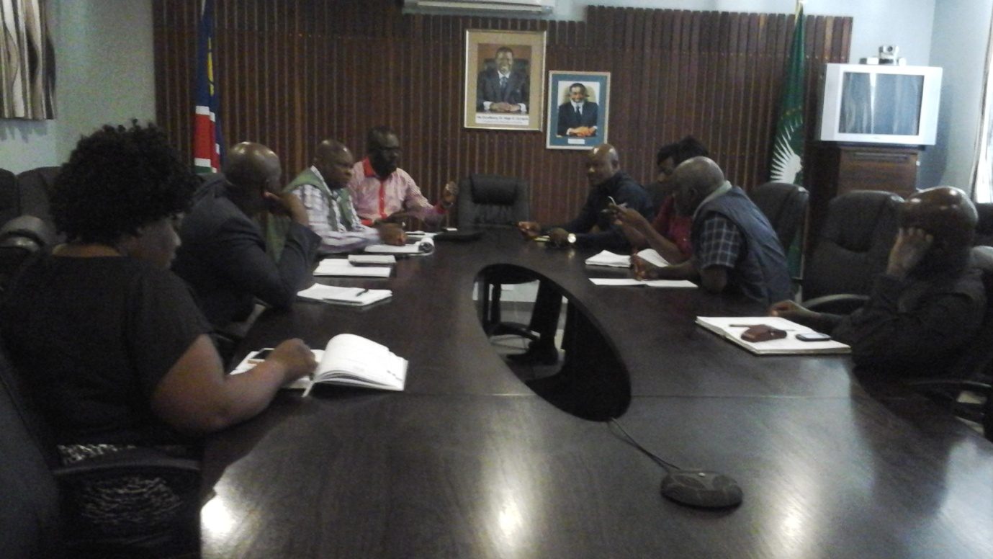

**ZAMBEZI FIELD WORK**

***Meeting With Community Members in Mafuta Village***

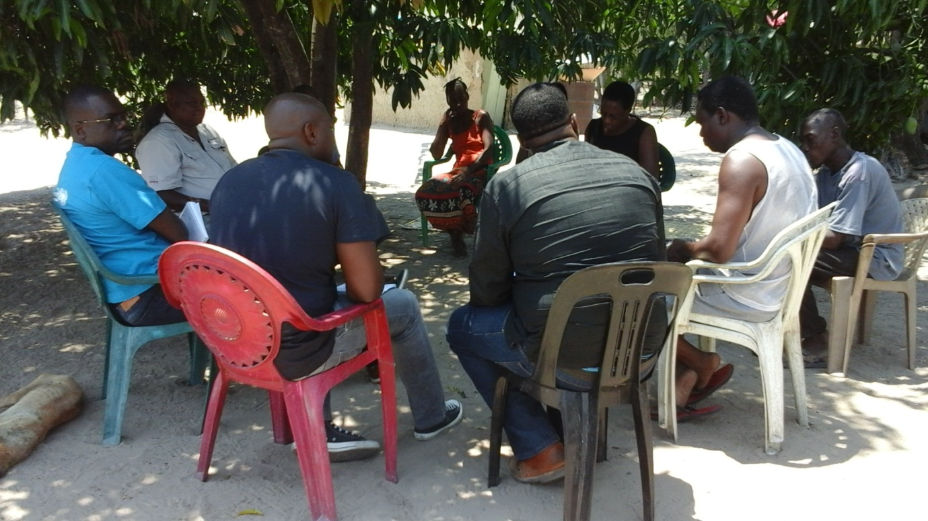

1. **Mafuta Village.**

Mafuta Village is in Katima Rural Constituency ward and was visited Friday 14/10/16 Mid-Morning.

Key Findings:

* The Village is a Peri - Urban Informal settlement with more than 80 Households, there no records for the village profile.
* This Village was triggered in June 2014, without any follow ups made for two years.
* Although a water point committee called Sepa Sahao Exists the Sanitation Action Group was not formed.
* Despite the lack of follow ups 17 households constructed their own latrines and are using them.
* Practice of Open Defecation has continued even among the 108 households who received Subsidy Latrines in Katima Rural Constituency.

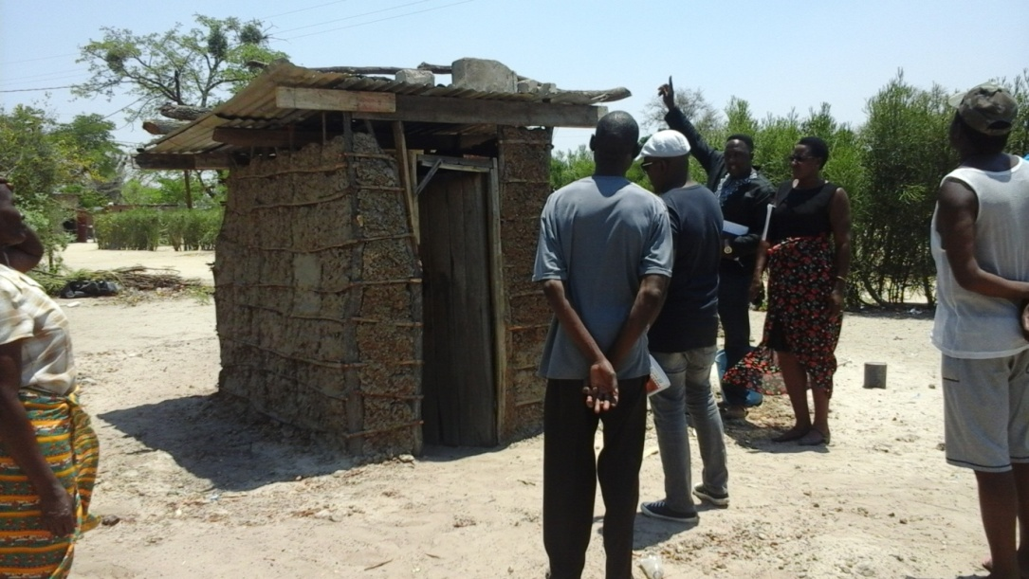

***A Latrine Constructed by one household in Mafuta Village.***

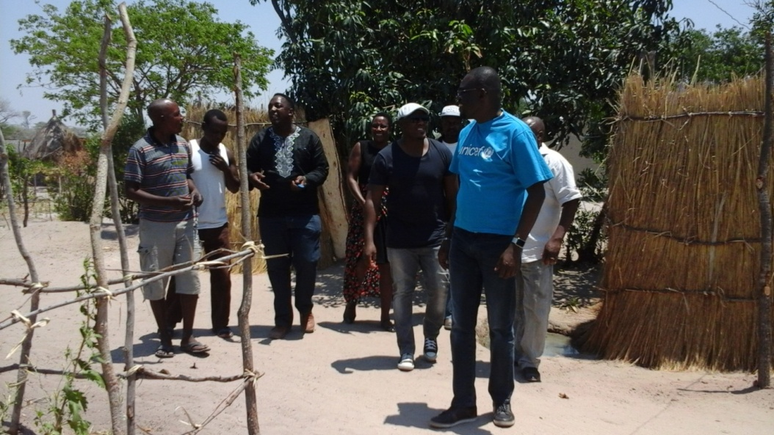

***Grass Covered Latrine and Bathing Shelter in Mafuta Village. One of the 17 latrines in that community after CLTS trigger in 2014.***

1. **Sachinga Village.**

This is a village located in Sibbinda Constituency. We visited the village on Saturday 15/10/16. The Village was triggered in June 2014. Just like Mafuta Village no post trigger follow up was made and Sanitation Action Groups were not formed to implement sanitation at community level. A clear gap in the service delivery chain was evidenced:

* 30 trainers of trainers done for Zambezi without cascading the Program to another management service level of training Community Champions.
* SAG Committees not formed to manage the Program at Community Level.
* Post trigger follow up Plans not developed to facilitate monitoring.
* Absence of Logistical support for Post – trigger monitoring and follow – ups.

Sachinga Village is heavily decorated with Subsidy Latrines which are provided only for the following groups of people but with low usage :

* The Elderly.
* The Village headmen or Induna.
* The Disabled.
* Family shared Latrines, One Latrine for 3 or 4 Families.

**Latrine used only by expecting mother while children go to the bush in Sachinga Village.**

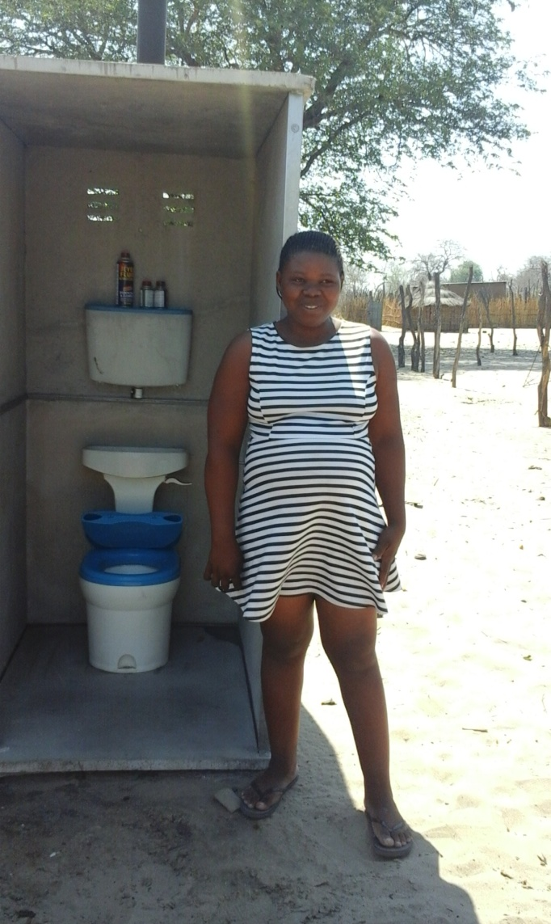

Zambezi Region received 1,600 VIP Latrines in 2014. These are expensive latrines each costing N$35,000. The Subsidy Approach coupled with poor application of CLTS has resulted in a ***“CLTS FAILURE TO THRIVE – CLTS FTT (CFTT),” in this region.***

**KAVANGO EAST REGION**

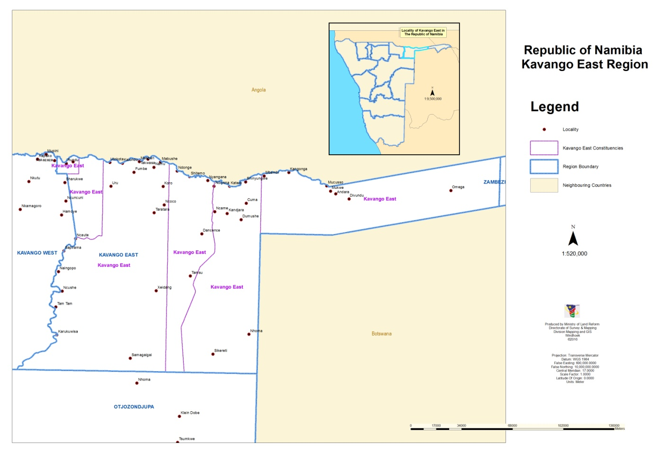

After a courtesy call on The Governor Dr. Samuel K. Mbambo on Monday 17th October 2016 a meeting was held with Members of the regional council. The regional council meeting was well attended, out of 12 members present 6 were Honourable Members of Parliament. The situation is the same as in Zambezi where the Sanitation Plan is not in Place and no budget for the same. The sanitation program is a Subsidy Government Driven. Kavango East region has 6 constituencies. 13 CLTS Facilitators were trained by SAREP in 2014. They triggered 6 Villages in Mashare Constituency, Ndongalinena and Rundu Rural.

**Kavango East Regional Council Meeting.**

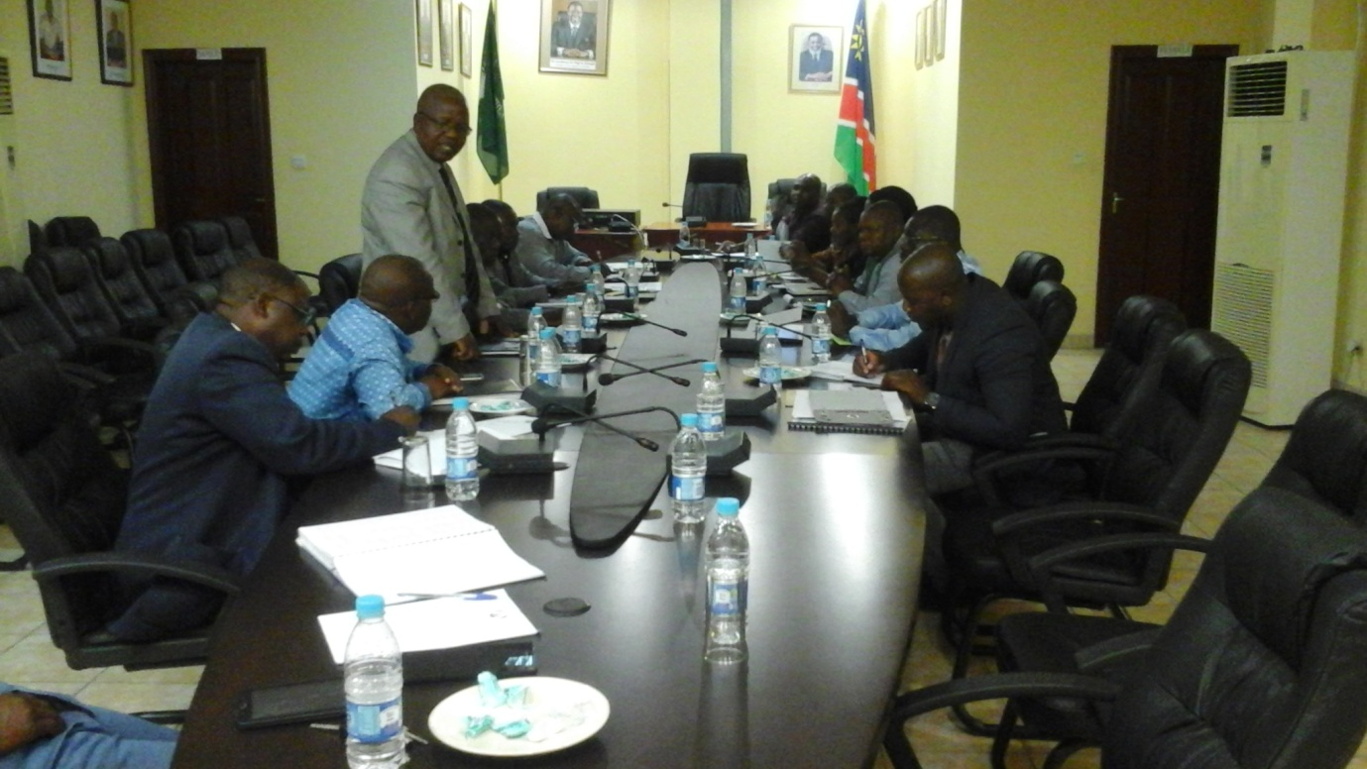

**VILLAGES TRIGGERED**

|  |  |
| --- | --- |
| Villages | Households. |
| Nyondo | 120 |
| Makandu | 102 |
| Katimba | 64 |
| Ngone | 66 |
| Diyana | 91 |
| Mashare | 70. |

**CONSTITUENCIES**

|  |  |  |
| --- | --- | --- |
| No | Const. | Population. |
|  | Mukwe | 27,690 |
|  | Mashare | 15,688 |
|  | Ndonga | 11,082 |
|  | Rundu Urban | 63,431 |
|  | Rundu Rural | 3,981 |
|  | Ndiyona | 9,551 |
|  | **TOTALS** | **131,401** |

Posing For a Photo with Governor for Kavango East. ***(Seated is Governor Dr. Samuel K. Mbambo a Cultural Anthropologist who is willing to Champion CLTS from Cultural Anthropological Dimension and bring understanding into Traditional Taboos).***

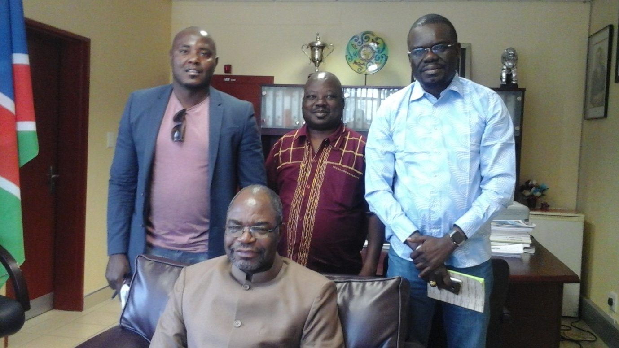

In 2015, 400 Latrines at N$35,000 each where constructed for each Household in the same villages. A field visit to two of these villages reviewed 10 (ten) limitations of subsidies as indicated below :

**10 LIMITATIONS OF A SUBSIDY APPROACH.**

1. Low Usage : There is low usage for subsidised toilets, majority of the people leave these

Expensive Latrines and continue with OD in the nearby Bushes.

(Sanitation Anorexia Nervosa)

1. Dependency: Even those who are able are still waiting for Government Latrines.
2. Not everyone is covered.
3. Technology cannot be replicated.
4. Poor Maintenance: Fixed Point Open Defecation.
5. Misuse: Latrines used as storage Facilities.
6. Lack of Ownership.
7. Vandalism.
8. Abandonment.
9. No Behaviour Change.

Because of the subsidy CLTS was suffered suffocation in the region.

**Poor Hygiene leading to Fixed point Open Defecation**

.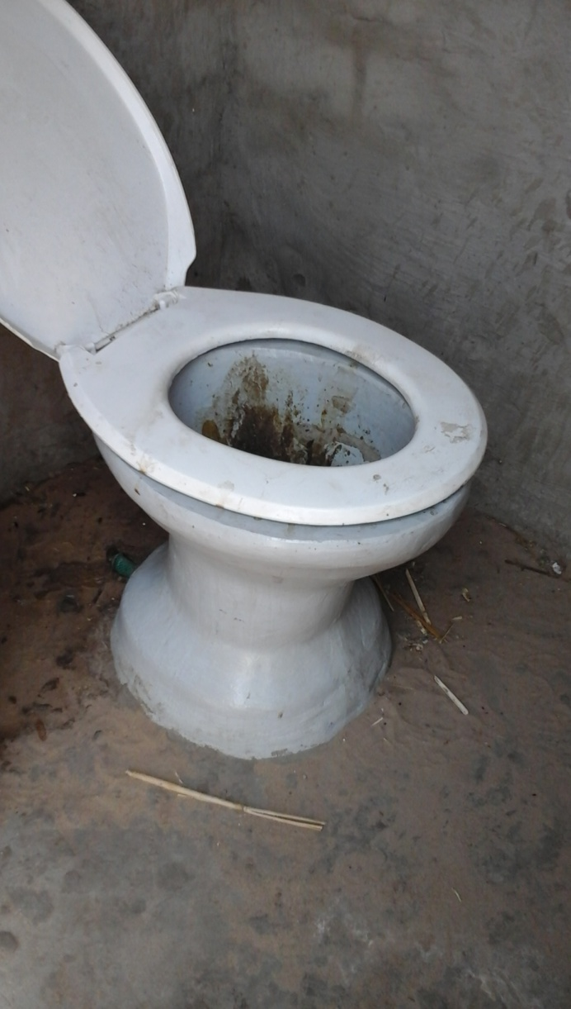

**Abandoned Latrine Gcawagi Village.EN**

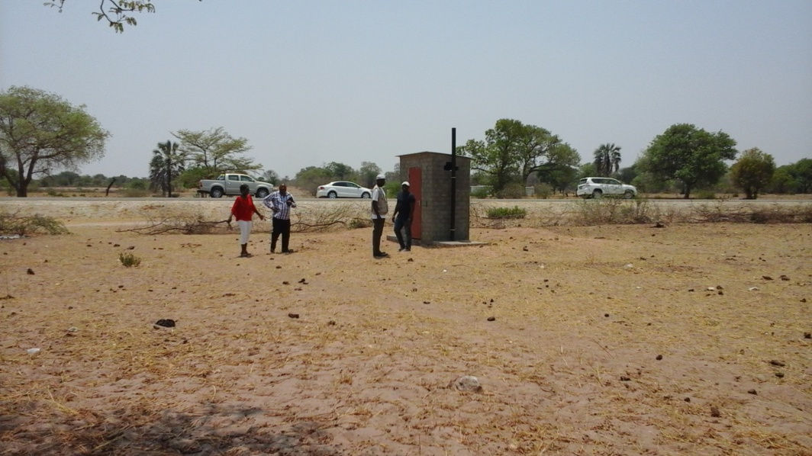

Lack of Ownership Leading to Vandalism.

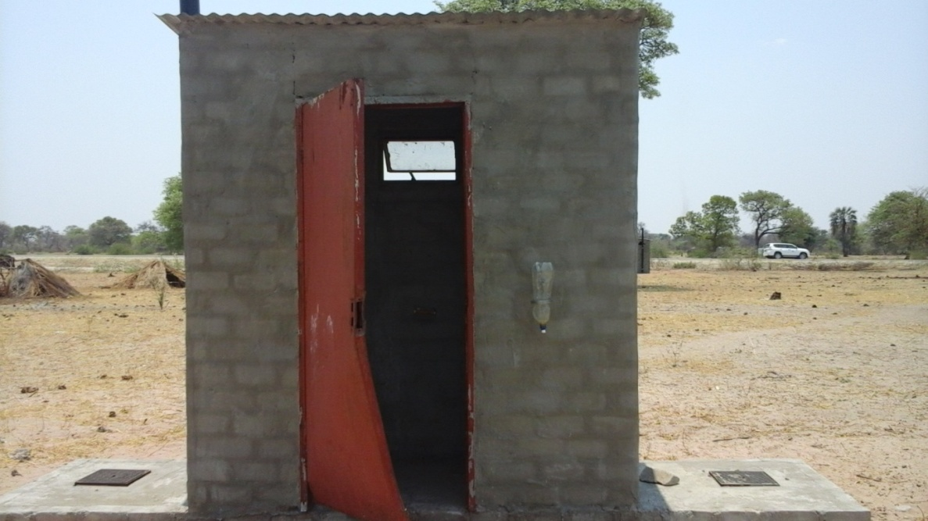

Misused Latrine and Abandoned.

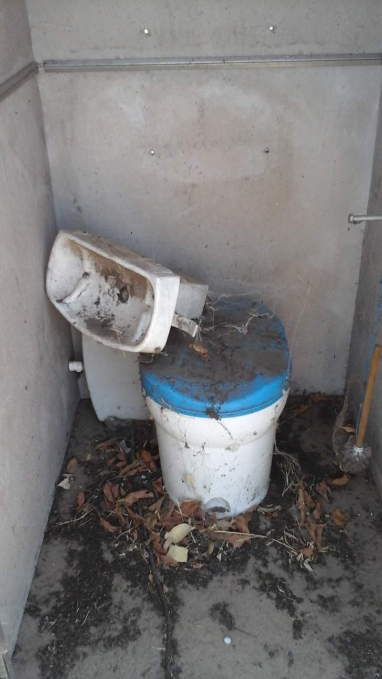

**KAVANGO WEST REGION**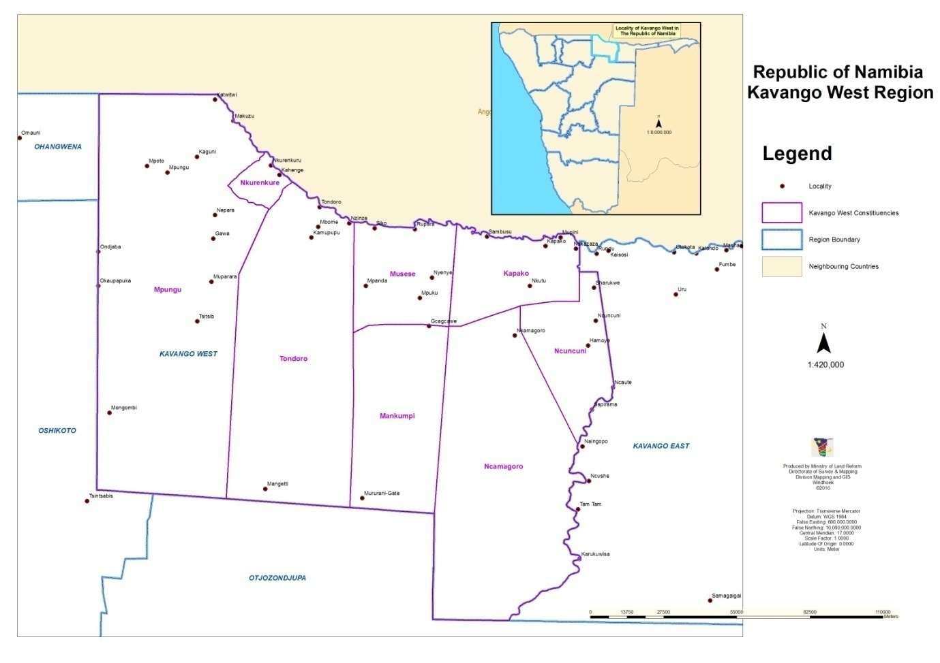

**Kavango West Regional Profile**

Kavango West is one of the fourteen [Regions of Namibia](https://en.wikipedia.org/wiki/Regions_of_Namibia). Its capital is [Nkurenkuru](https://en.wikipedia.org/wiki/Nkurenkuru). The Region was created in 2013 when the [Kavango Region](https://en.wikipedia.org/wiki/Kavango_Region) was split into [Kavango East](https://en.wikipedia.org/wiki/Kavango_East) and Kavango West. The population of **107,905 inhabitants** as per 2011 census reside in Kavango West Region.

In the north, Kavango West borders the [Cuando Cubango](https://en.wikipedia.org/wiki/Cuando_Cubango) Province of [Angola](https://en.wikipedia.org/wiki/Angola). Domestically, it borders the following regions:

* [Kavango East](https://en.wikipedia.org/wiki/Kavango_East) – east
* [Otjozondjupa](https://en.wikipedia.org/wiki/Otjozondjupa) – south
* [Oshikoto](https://en.wikipedia.org/wiki/Oshikoto_Region) – west
* [Ohangwena](https://en.wikipedia.org/wiki/Ohangwena_Region) – northwest

Because of its rather higher rainfall than most other parts of Namibia, this region has agricultural potential for the cultivation of a variety of crops, as well as for organized forestry and agro-forestry, which stimulates furniture making and related industries.

The region is subdivided into eight [electoral constituencies](https://en.wikipedia.org/wiki/Constituencies_of_Namibia):

[***Kapako***](https://en.wikipedia.org/wiki/Kapako_Constituency) ***Constituency***

Kapako is a constituency in the [Kavango West](https://en.wikipedia.org/wiki/Kavango_West) region of [Namibia](https://en.wikipedia.org/wiki/Namibia). It has 25,653 inhabitants, the district centre is the settlement of [Kapako](https://en.wikipedia.org/w/index.php?title=Kapako&action=edit&redlink=1).The constituency contains the settlements of [Gcugcuma](https://en.wikipedia.org/w/index.php?title=Gcugcuma&action=edit&redlink=1) and [Siyandeya](https://en.wikipedia.org/w/index.php?title=Siyandeya&action=edit&redlink=1). There is a bilateral agreement with [Angola](https://en.wikipedia.org/wiki/Angola) to allow mutual near-border immigration without travel documents. This applies to a maximum distance of 30 km, it is invalid for tourists.

[***Mankumpi***](https://en.wikipedia.org/wiki/Mankumpi_Constituency) ***Constituency***

 The administrative centre of Mankumpi Constituency is the village of [Satotwa](https://en.wikipedia.org/w/index.php?title=Satotwa&action=edit&redlink=1)

[***Mpungu***](https://en.wikipedia.org/wiki/Mpungu_Constituency) ***Constituency***

Mpungu constituency has a population of 18,332.

[**Musese**](https://en.wikipedia.org/wiki/Musese_Constituency) **Constituency**

Musese Constituency has 10,011 inhabitants

[**Ncamangoro**](https://en.wikipedia.org/wiki/Ncamangoro_Constituency) **Constituency**

[**Ncuncuni**](https://en.wikipedia.org/wiki/Ncuncuni_Constituency) **Constituency**

It has 8,541 inhabitants

[**Nkurenkuru**](https://en.wikipedia.org/wiki/Nkurenkuru_Constituency) **Constituency**

[**Tondoro**](https://en.wikipedia.org/wiki/Tondoro_Constituency) **Constituency**

**Stakeholders**

Kavango West Regional Council

Ministry of Agriculture, Water and Forestry

Ministry of Health and Social Services

Ministry of Labour and Employment Creation

Ukwangali Traditional Authority

Mbunza Traditional Authority

Ministry of Gender and Child Welfare

Ministry of Veterans Affairs

Ministry of Basic Education and Culture

Ministry of Youth and Sport

Ministry of Defence

Ministry of Safety and Security

Nkurenkuru Town Council

Ministry of Environment and Tourism

In Kavango West Region we met the regional council as well as The Regional Director of Health Ms Timea Ngwira who is based in Kavango East but covers both regions. No tress of CLTS activities was visible in this region. The Regional Council complained of low usage of these subsidized Latrines which are provided at high cost. The even indicated that in one village called Gcawagi some 40 km towards Kavango East the entire Village has been abandoned leaving these expensive latrines alone.

Gcawagi Village

**( Gcawagi is a village about 40km from Kavango West as you go to Kavango East. The People have abandoned this village leaving Expensive Latrines behind. A few households still remaining in the village use these Latrines as storage facilities)**

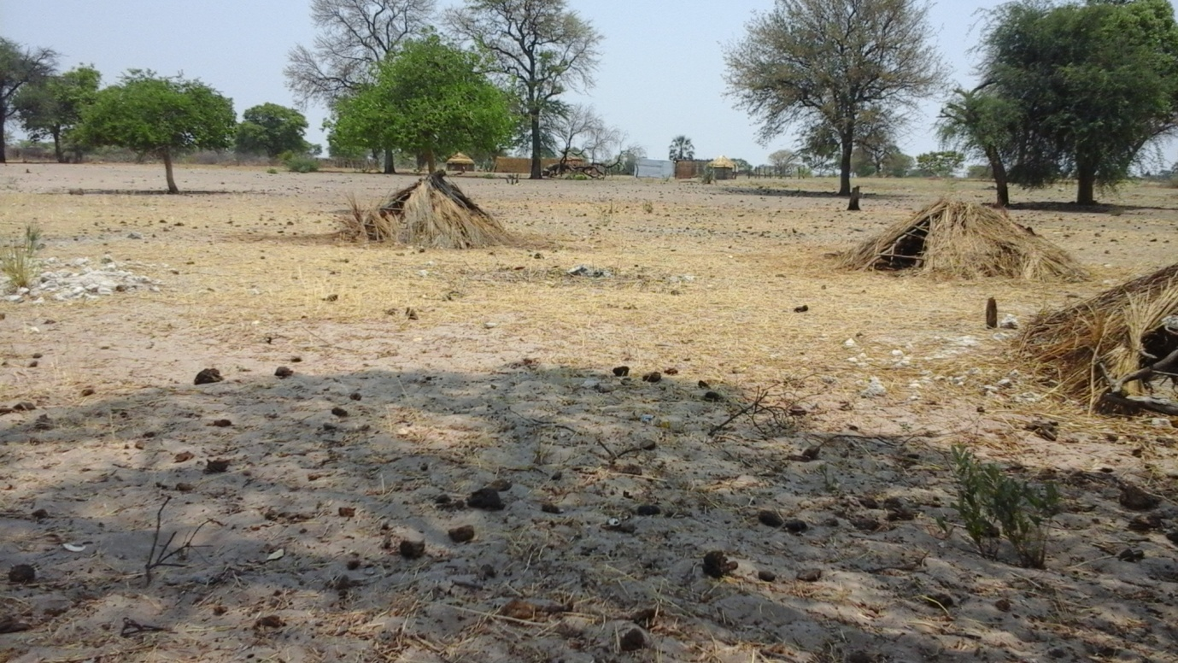

**OHANGWENA REGION**

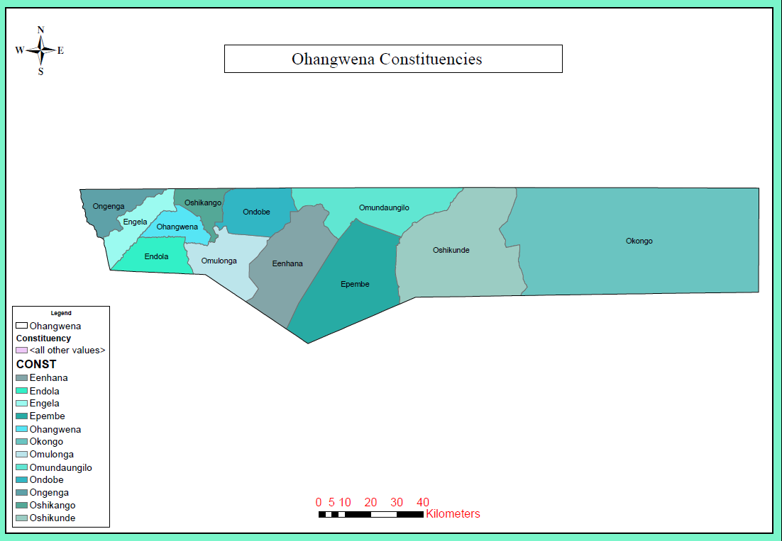

OHANGWENA REGIONAL PROFILE

**POPULATION SIZE**

Total Population: 245 446

Females: 133 316

Males: 112 130

**CONSTITUENCIES AND NO. OF HOUSEHOLDS**

|  |  |
| --- | --- |
| **CONSTITUENCY** | **NO. OF HOUSEHOLD** |
| 1. **Ohangwena** | **3153** |
| 1. **Eenhana** | **3982** |
| 1. **Endola** | **4654** |
| 1. **Engela** | **4903** |
| 1. **Epembe** | **2568** |
| 1. **Okongo** | **4773** |
| 1. **Omundaungilo** | **1169** |
| 1. **Ondobe** | **3851** |
| 1. **Ongenga** | **3887** |
| 1. **Oshikango** | **5378** |
| 1. **Omulonga** | **5405** |
| 1. **Oshikunde** | **Not known yet** |

**SANITATION STAKEHOLDERS**

1. Ministry of Health and Social Services
2. Ministry of Education, Arts and Culture
3. Ohangwena Regional Council
4. Red Cross Namibia
5. Ministry of Information and Technology
6. Town and Village Councils

**SIZE OF THE REGION**

Ohangwena Region covers an area of 10,703 KM2

From Wednesday 19 – Thursday 27/10/16 we spent time in Ohangwena in the field as well as TOT training. The TOT training details are covered in the training report.

This is a region with the highest number of CLTS trained Facilitators. In 2014, 45 Facilitators were trained by SAREP. An addition number of 23 from Namibia Red Cross were trained in 2015 bringing the total number to 68. Namibia Red Cross piloted CLTS in 5 Villages with support from UNICEF.

UNICEF RED CROSS SUPPORTED CLTS IMPLEMENTATION IN OHANGWENA.

This was a one year Project Cooperation Agreement ( PCA ) signed between Unicef and Namibia Red Cross to trigger 5 villages. At the beginning of the year the following activities, project results and outcomes where outlined:

Proposed Activities.

1. Conduct Community WASH Education sessions on prevention of cholera and watery diarrhoea.
2. Train Health volunteers in CLTS.
3. Conduct base line survey in selected villages for CLTS trigger.
4. Trigger CLTS in 5 villages.
5. Print training resources and teaching aids.
6. Document the process, outputs and outcomes and develop a concept paper for future replication in other regions.
7. Appoint dedicated NRCS employees and other support staff to project manages for duration of the implementation period.

Expected project results.

1. 70% of the target population have hand washing facilities.
2. At least 5 villages in Ohangwenya are certified Open Defecation Free.
3. Lessons learned and project outcomes are recorded and shared with relevant stakeholders.

Expected Project Outputs.

1. Baseline CLTS survey carried out in at least 5 village.
2. 20 Namibian staff are trained in CLTS.
3. Traditional leaders from at least 5 selected villages are trained in CLTS.
4. Documentation of lessons learnt.
5. Monitoring and Evaluation reports.

PROJECT BUDGET.

|  |  |  |
| --- | --- | --- |
| **S/N** | **ACTIVITY DESCRIPTION** | **AMOUNT ( N$ )** |
| 1 | Conduct community WASH Education on prevention of diarrhoea. | 50,000 |
| 2. | Conduct Household water treatment demonstration | 25,000 |
| 3. | Conduct Global Hand Washing Day ( GHWD ) | 25,000 |
| 4. | Conduct Sensitization about CLTS and Sanitation. | 5,000 |
| 5. | Train Health Volunteers in CLTS Approach and Baseline survey methods. | 70,000 |
| 6. | Conduct baseline survey in villages selected for CLTS triggering. | 10,000 |
| 7. | Trigger CLTS in 5 villages in Ohangwena. | 100,000 |
| 8. | Conduct Weekly Follow Ups in triggered villages. | 50,000 |
| 9. | Conduct Monitoring & Evaluation Activities | 20,000 |
| 10 | Fuel & Vehicle Maintenance | 48,000 |
| 11 | Total Project Support Cost | 403,000 (26,866 USD ). |

**5 CLTS VILLAGES TRIGGERED BY NAMIBIAN RED CROSS.**

|  |  |  |  |  |  |  |
| --- | --- | --- | --- | --- | --- | --- |
| **No** | **Village.** | **H\Hs** | **POP** | **CONST.** | **LATRINES. BEFORE.** | **CURRENT LATRINES.** |
|  | Ondingwanyama | 68 | 655 | Eehana | 7 | 68 |
|  | Otaukonjele | 177 | 900 | Ondombe | 57 | 113 |
|  | Eengonyo | 95 | 1400 | Ondombe | 5 | 74 |
|  | Oheti | 85 | 1052 | Ondombe | 27 | 51 |
|  | Ohaihana | 104 | 804 | Eehana | 27 | 57 |
|  | TOTALS | **529** | **4811** |  | **123** | **363** |

In 2015 Unicef signed a one year PCA with Namibia Red Cross to Pilot CLTS in 5 Villages listed above. Training for staff from Red Cross was conducted from 31st August to 8th September 2015. The training consisted of 5 Regional Managers from Ohangwena, Oshikoto, Omusati, Kunene and Kavango, Four District Staff from Ohangwena, Oshikoto and Kunene, 15 Volunteers from Ohangwena, Omusati, Kunene and Kavango.

NAMIBIA RED CROSS CLTS PROJECT ANALYSIS

1. Project Size: 529 Households.
2. Project Effectiveness: 68 % (ODF households divided by triggered households multiplied by 100).
3. Value For Money ( VFM ) : N$1,110 or 74 USD Cost of a Latrine ( Project Cost Divided by Latrines Produced).
4. Average Expected ODF duration per village when CLTS is properly applied – 3 to 4 months.

**FINDINGS FROM THE FIELD.**

1. Although 23 CLTS Facilitators were trained from 5 regions ( Ohangwena, Oshikoto, Omusati, Kunene and Kavango ) only participants from Ohangwena had the privilege of experiential learning of post trigger follow ups in the 5 Villages. This was because of the logistical support that was tied to 5 Villages in harmony with the PCA signed by Red Cross & Unicef.
2. Involvement of traditional leadership and youths is very important to the success of. CLTS. In Ondingwanyama Village, the village head man and his wife took the lead in spearheading CLTS in their community and this helped the village to become ODF.
3. The SAG Chairperson Ephraim in Ondingwanyama village is a youth who is very active. He mobilised his fellow youths to work as one team for latrine construction including supporting the Elderly by constructing latrines for them.
4. Seven House Holds in Ondingwanyama have already moved up the Sanitation Ladder by building flush Toilets.
5. Latrines constructed by the communities themselves are so much cherished and used.
6. Collapsing of Latrines gives the community an opportunity to innovate what is workable and lasting. In Ondingwanyama village the community have innovated what is called a tyre latrine where they use old tyres for pit lining because the sandy soils that easily collapse.
7. After these communities where triggered other meetings were held calling for registration of Free Subsidy latrines from Government. This contributed a lot to communities stopping latrine construction in the other four villages with a weak traditional leadership.
8. Headman Ondingwanyama, His Wife and Ephraim the SAG Chairperson are now CLTS Champions who have made their Village the First ever ODF Village in Namibia.

EXTENT AND EFFECT OF SUBSIDY.

Since 2012, MAWF Constructed 1,050 Latrines in various Constituencies in Ohangwena region:

* Ongenga Constituency ---------------------------- 107 Latrines.
* Omundaungilo Constituency -------------------- 53 Latrines.
* Ohangwena Constituency ------------------------ 482 Latrines.
* Epembe Constituency ----------------------------- 408 Latrines.
* In Addition to that the Ohangwena regional Council Constructed 2,783 Latrines in the region and are planning to Construct 240 this Financial year.
* A total of 3, 833 Latrines have been constructed in the region at a cost of N$35,000.
* Ohangwena has a population of 245,446 and 43,723 households. Given that in the passed 4 years 2,783 Latrines have been provided 700 per year it would take 62 years to cover each household with a latrine.
* The above clearly shows that subsidy for Namibia is more of a hindrance than a solution to the 1.2 million people practicing OD.
* Namibia Red Cross now have seasoned CLTS Facilitators and could be very helpful in Piloting CLTS at Constituency level in Ohangwena. Considering the Financial Support they got from Unicef however, they could have triggered more than 5 villages and demonstrated Value for Money ( VFM ). The amount of Money received for the program against the latrines constructed leaves one latrine at USD 74. The Project Size was too small for the logistical support provided with a training of 23 Facilitators against 5 villages, that is 4.6 Facilitators per village is more than too much compared to the ratio of One Champion to 5 or 10 villages.

**Ondingwanyama the First ODF Village in Namibia.**

**Improved Sanitation in Ondingwanyama Village. One of the seven water borne toilets**

**Built at N$ 7000 .( For Mr. Ephraim Shindiwe )**

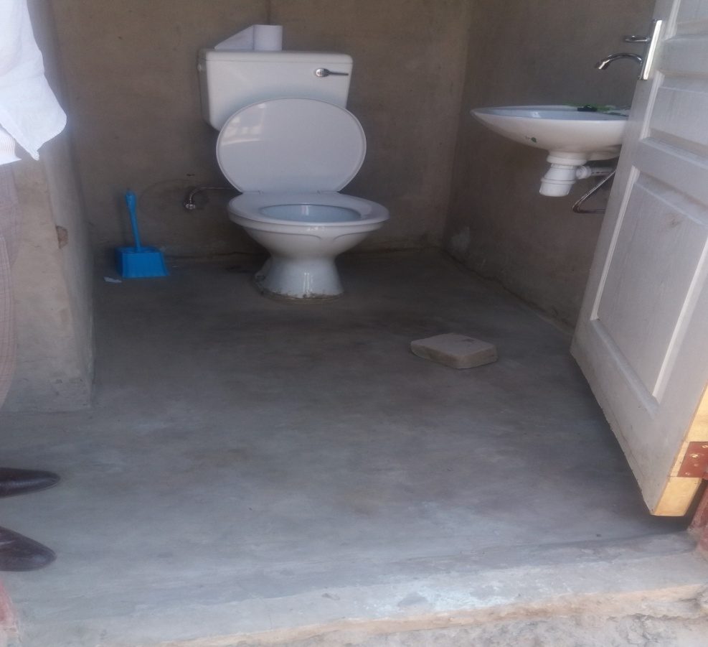

**Innovations of old tyre Latrines in Ondingwanyama Village.**

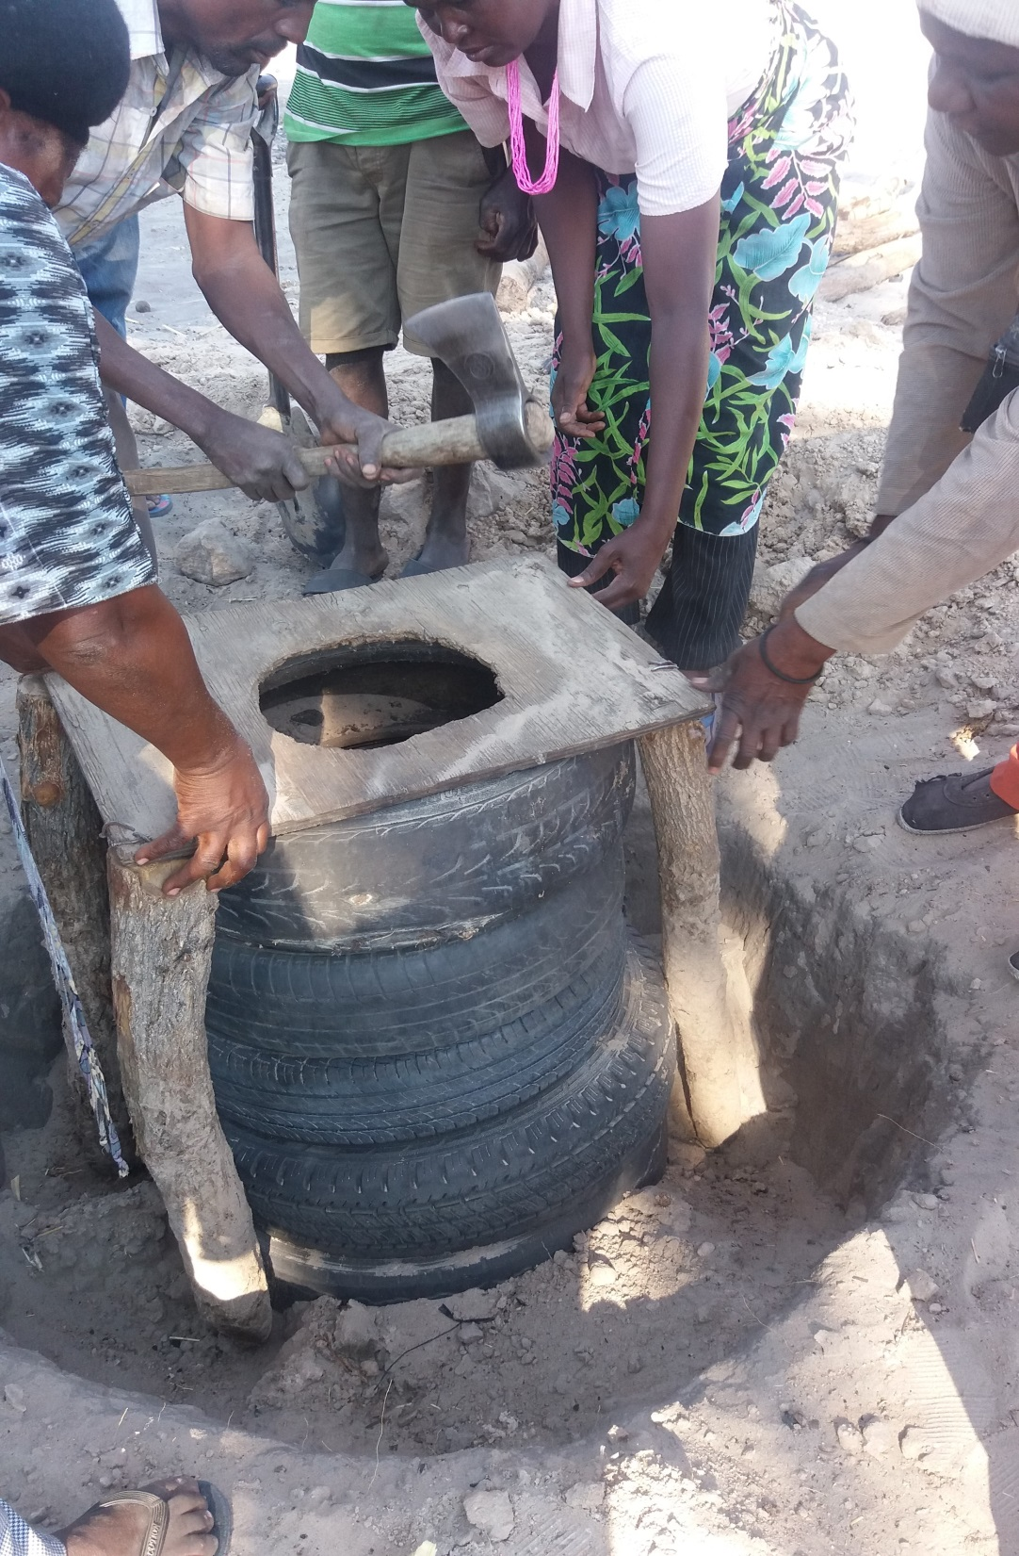

**Lessons from Ondingwanyama Village.**

1. Consistent Post Trigger Follow Ups are very important and are not optional.
2. Traditional Leadership is key to the success of the program.
3. Team work involving all key players makes work enjoyable and easy for everyone. Latrine construction becomes like a game instead of been viewed as un achievable hard work.
4. Experiential Learning, Creativity and innovations can only be achieved when communities do the construction themselves and it is up to them to find solutions to collapsing latrines and fix things (Old Tyre Latrines Innovations ).
5. A mixture of Youths, Elderly Men and Women, Local business persons, provides special strength to SAG Team.
6. Wives of head men have an influential role on women in the village as was seen by the example of Head man Ondingwanyama’s wife who took an active part in latrine construction and offered herself as member of the SAG Committee.

**SUMMARY OF CLTS PROGRESS IN THE FOUR REGIONS FROM 27th May 2013 to 27th OCTOBER 2016**.

|  |  |  |  |  |  |
| --- | --- | --- | --- | --- | --- |
| **TOT W/SHOP** | **PARTICIPANTS** | **TRIGGERED VILLAGES** | **FOLLOW UPS** | **LATRINES BUILT** | **ODF VILLAGES** |
| 27/05/13 1/06/13 | 30 | 13 | 0 | 0 | 0 |
| APRIL 2014 | 42 | 13 | 0 | 0 | 0 |
| SEPT 2014 | 45 | 13 | 0 | 0 | 0 |
| 31 AUG – 8/09/2015 | 23 | 05 | 6WKS PLAN | 363 | 1 |

**ANALYSIS OF CLTS IN NAMIBIA FOR THE PAST 3 YEARS.**

1. Enough Financial allocations should be put aside to support a full range of CLTS Implementation. Namibia Red Cross for example confined themselves only to 5 villages despite interest shown by other neighbouring villages.
2. TOT Trainings are not the end but the begging of a CLTS Program, in the initial four TOTs community champions were no trained and yet these are the once that directly communities.
3. After a TOT Workshop Community Champions should be trained who will directly trigger CLTS at Community Level.
4. Sanitation Action Groups should be formed and gradually trained in their roles and responsibilities.
5. Consistent Follow up plans should be made and adhered to after each trigger. In the Four regions trainings where done and no follow ups made for a period of two years.

**KEY CHALLENGES.**

1. **FUNDING.**

Sanitation is not funded; the only money that is made available for sanitation is under the arrangement where latrine construction is advertised to engage a constructor who moves into the community to construct latrines which are very expensive ( N$ 35,000 each).

1. **PLANNING AND BUDGETTING.**

Even at the lead Ministry which is The Ministry of Agriculture Water and Forestry there are no Plans for Sanitation. The Situation is the same with other line ministries from national to constituency level.

1. **COORDINATION MECHANISMS.**

The Ministry of Agriculture Water and Forestry is mandated to Coordinate Sanitation. Structures such as Water and Sanitation Forum ( WATSAN) do exist on paper but do not meet as scheduled. WATSAN Forum is a pour of all sanitation actors at national level. This team of multi-sect oral sanitation actors is supposed to meet every quarter but only met once in the first quarter this year. History showed that the meetings used to be regular and well attended when the Forum was funded by USAID. Over time and with that support coming to an end decision makers who used to attend only delegate to junior officers. Another Body for Coordination is called the Inter-Ministerial Committee which is also supposed to meet quarterly but only met once in 2014.

1. **FUNCTIONAL LINKAGES AMONG 4 KEY LINE MINISTRIES.**

There are four Key line government ministries: MAWF, MURD, MoE and MoHSS. Ministry of Agriculture Water Forestry is the lead ministry responsible for coordination, Policy direction and sourcing funds for sanitation. The Ministry of urban and rural development have been given the mandate to construct latrines. Ministry of Education is responsible for school sanitation while Ministry of Health and Social Services is in charge of hygiene promotion. With good functional linkages among these four ministries the sanitation agenda for Namibia could be taken care of very well. Unfortunately there are no Functional Linkages within ministries and among the four sanitation giants. Each Ministries works independent of the other and none has a Sanitation Plan. The Ministry of Education has a memorandum of understanding ( MOU), with Ministry of Health and Social Services and provide hygiene education in schools.

1. **SUBSIDY.**

The provision of subsidized latrines is one of the main killers to development and growth of CLTS in Namibia. This is the more reason why Namibia Red Cross failed to deliver the 5 villages ODF within a year despite 23 people trained in CLTS. During a field visit to Eengonyo Village for instance the SAG members indicated that soon after trigger another meeting was individual households constructing their own latrines.

SANDY held in the village for registration of subsidized latrines. This put an immediate hold on to.

1. **SOILS AND FLOODS**.

Another limiting factor especially in the four regions of the north is soil formation which is sandy resulting in collapse of latrines. This led to Ondingwanyama village innovation of old tyre latrines. 12 old tyres are put into the pit to prevent curving in of the soils. These tyres are bought at N$50 for 10 tyres. The fact that people in Ondingwanyama came up with this innovation and are willing to pay for it is a good indicator of behaviour change and that CLTS works.

1. **LACK OF CLEAR SANITATION APPROACH TO FOLLOW.**

Namibia claims to apply both PHAST and CLTS approaches. PHAST approach has a component of subsidy although this is not 100%. On the other the name CLTS is used when what is done in the communities is the usual sensitization on hygiene without the spirit of CLTS and application of the tools, there is triggering taking place. Hence the missing of the Psycho sensory Emotional trigger factors such as Embarrassment, Guilty, Fear Disgust, Shame: The EG- FDS Factors. As such a lot is missing in what is un knowingly called CLTS in Namibia.

1. **CLTS NOT CLEARLY ARTICULATED IN POLICY DOCUMENTS.**

While there is some mention of CLTS in The National Sanitation Strategy in two places of the entire document as well as The ODF Namibia Communication Strategy there is need to have CLTS clearly articulated as a workable sanitation approach for Namibia. A document that put CLTS in its clear perspective and how it is implemented will be very helpful to all sanitation actors.

**RECOMMENDATIONS.**

1. **The Ministry of Agriculture Water and Forestry :**
2. Should appoint a Sanitation Coordinator under the Directorate of Water Supply and Sanitation Coordination (DWSSC), who should spearhead CLTS with other Stakeholders.
3. Establish Functional Linkages among the Four Key Line Ministries (MAWF, MURD, MoHSS and MoE) and ensure that respective roles of these line ministries are well coordinated.
4. As a lead Ministry, MAWF should ensure that WATSAN Forum is re-activated and meets regularly.
5. To Ensure Formation of The National CLTS Task Force consisting of the four key line ministries and Unicef as a Specialised Subcommittee to the WATSAN Forum.
6. Develop a National Sanitation Plan and ensure that it has financial support from Government.
7. Support the formation of CLTS Task Forces at regional and constituency levels.
8. Develop a CLTS Implementation Plan and ensure that CLTS is well articulated with Cabinet level support.
9. Develop a Sanitation Data Base at National Level and ensure that Monitoring Systems are in place to truck down a complete sanitation service delivery.
10. MAWF should ensure prompt verification and certification of Ondingwanyama village and arrange for ODF Celebration before end of 2016.
11. **MINISTRY OF URBAN AND RURAL DEVELOPMENT (MURD).**
12. The MURD should make arrangements working with Unicef and Ministry of Health to ensure a Post Construction trigger of all villages where Latrines have already been provided under subsidy so that communities are triggered to use these facilities and can be certified later as ODF.
13. The 50,000 Harambee Prosperity Plan Latrines Should be provided as a reward to ODF Villages such as Ondingwanyama as a Sanitation Ladder and ODF Sustainability Support.
14. Ensure that Harambee Prosperity Plan Latrines are constructed by communities themselves using trained youths as masons who will conduct mass community trainings ( MCTs) for Latrine Construction after CLTS triggers. As provided in the HPP this will ensure job creation for the unemployed local youths at least 60 per constituency (Total: 7,260 jobs created) and this will multiply the 50,000 to 250,000 Latrines from N$35,000 to N$7000 or Less per Latrine. 250,000 Latrines is what is needed to cover 1.2 million people in Namibia practicing OD.
15. **TRAINING NEEDS RECOMMENDATIONS.**
16. One Day orientation Meeting for WATSAN Forum on Sanitation Approaches – 4th Week of February 2017.
17. Seven Days Community Champions Training in CLTS & Baseline Survey – 1st Week of March 2017.
18. Master Trainers Training in Communication & Facilitation Skills for Three Days – 2nd Week of March 2017.
19. Latrine Builders/Masons Training for Eight Days – 3rd to 4th Week of March 2017.
20. **CLTS CHAMPIONS & NATURAL LEADERS RECOMMENDATIONS.**

The following people were recognized as Champions with special and unique interest in CLTS and deserve further Coaching and exposure:

* Headman Ondingwanyama and his wife.
* Ephraim Tutaleni ( Ondingwanyama SAG Chairperson)
* Maria Mwakeme ( NRCS).
* Justine Kulla Petrus ( ag. Chief Env. Practitioner MoHSS, Ohangwena ).

**CONCLUSION**

Namibia is a low hanging Fruit among the more than 65 countries practicing CLTS Worldwide. With a small population (1.2 Million) people practicing OD it is expected that Namibia could lead the way of Countries becoming ODF within the next two years 2017/2018. The Availability of an Enabling Environment which among others include:

* Well developed Sanitation Policies and Frame Works.
* WATSAN Forums at National & Regional Levels.
* A young, trainable and active Labour Force.
* High quality life, Peace and Social Stability.
* Inter-Ministerial committee on Sanitation.
* Small Population Practicing OD

Unless this E&E is tapped into and made good use of achievable benefits will not be achieved. If the Subsidy arrangement continues in the current manner of implementation it will take Namibia another 40 years of fighting Open Defecation, this requires re-thinking & re-planning so that we see a change in the 52% mortality of under one year, 24% stunting reversed and 6% wasting becoming History. This can be done because it is doable with the right approach to sanitation.